

**Rajshahi Officers Housing Scheme**

**Land Base ERP Software**



**DEVELOPED BY**

**ICON INFORMATION SYSTEMS LTD**

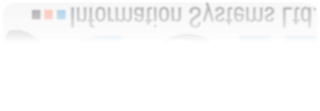

**Reference Page**

**SL NO Description Page**

### 1 Login Page ……………………………………………………………… 1

**2** **Dashboard** **…………………………………………………………………… 2**

**ACCOUNT**

**3** **Chart Of Account**  **……………………………………………………………… 2**

**4** **Subsidary Ladger**  **………………………………………………………………………….. 2**

**5** **Opening Balance**  **…………………………………………………………………………. 3**

**6** **Debit Voucher**  **………………………………………………………………………… 4**

**6.1** **All Debit Voucher**  **…………………………………………………………………………… 6**

**7** **Credit Voucher**  **………………………………………………………………………………… 7**

**7.1** **All Credit Voucher**  **……………………………………………………………………………… 9**

**8** **Contra Voucher**  **………………………………………………………………………………… 10**

**8.2** **All Contra Voucher** **………………………………………………………………………………….. 12**

**9** **Bank to Bank Loan** **……………………………………………………………………………………**

**9** **Journal Voucher**  **…………………………………………………………………………………… 13**

**9.2** **All Journal Voucher**  **………………………………………………………………………………. 15**

**10.1.1** **Land Payment**  **…………………………………………………………………………………………. 18**

**10.1.2** **Member Payment**  **…………………………………………………………………………………….. 19**

**10.1.3** **Leach Payment**  **…………………………………………………………………………………………… 20**

**11.1** **Payment** **……………………………………………………………………………………………………**

**LAND**

**1** **Supplier (Land owner) info**  **……………………………………………………………………………….. 1**

**2** **Media Info**  **………………………………………………………………………………………………………. 2**

**3** **Land Details**  **…………………………………………………………………………………………………….. 3**

**4** **Land Deed Details**  **…………………………………………………………………………………………….. 4**

**5** **Land Price Circulation**  **……………………………………………………………………………………….. 5**

**MEMBER**

**1** **Member Details**  **……………………………………………………………………………………………… 1**

**2** **Bayna Land Details**  **…………………………………………………………………………………………. 2**

**LEACH**

**1** **Leachman info**  **……………………………………………………………………………………………… 1**

**2** **Deed Land Leach**  **…………………………………………………………………………………………….. 2**

**APPROVE**

**1** **Voucher Approve**  **……………………………………………………………………………………………. 1**

**2** **Land Deed Approve**  **……………………………………………………………………………………… 2**

**3** **Member Deed Approve**  **………………………………………………………………………………… 3**

**4** **Leach Deed Approve**  **……………………………………………………………………………………… 4**

**5** **Payment Received Approve**  **………………………………………………………………………….. 5**

**6** **Payment Payable Approve**  **…………………………………………………………………………… 6**

**REPORT LIST**

**1** **Ledger Wise Transection**  **………………………………………………………………………………… 1**

**2** **Daily Transection**  **…………………………………………………………………………………………… 2**

**3** **Land Cost Analysis**  **…………………………………………………………………………………………. 3**

**4** **Media Report**  **………………………………………………………………………………………………… 4**

**5** **Member Report**  **……………………………………………………………………………………………… 5**

**6** **Leach Report**  **………………………………………………………………………………………………… 6**

**7** **Dugh No Wise Land Details**  **…………………………………………………………………………… 7**

**8** **Total Land Purchase And Sale Report** **……………………………………………………………… 8**

**9** **Land Wise Report**  **…………………………………………………………………………………………. 9**

**10** **Details Of Development Contribution**  **……………………………………………………………. 10**

**11** **Payment Details Against Media**  **……………………………………………………………………… 11**

**12** **Loan Report**  **…………………………………………………………………………………………………..**

**13** **Land wise Plot report**  **……………………………………………………………………………………….**

**DATA SETTING**

**1** **Employee Info**  **……………………………………………………………………………………………….**

**2** **Designation** **………………………………………………………………………………………………….**

**Person Loan**

1. **Loan Person Info**  **…………………………………………………………………………………………**
2. **Money Lender**  **…………………………………………………………………………………………….**
3. **Loan Approve**  **……………………………………………………………………………………………..**

**Plot**

**1** **plot Distribution**  **…………………………………………………………………………………………….**

**2** **plot measurement**  **…………………………………………………………………………………………**

**Login Page**

* Please insert the Email
* Password Value than
* Sign me in button click than
* Dashboard Open

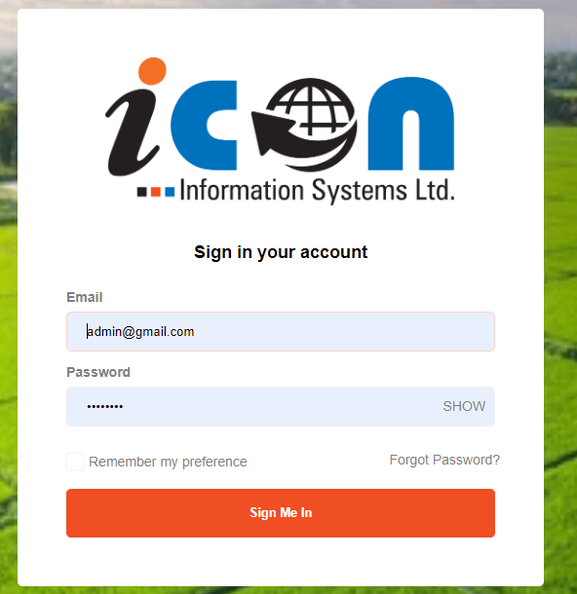

**Dashboard Page**

* **Software total employee and total income and total expense and loss profit and land overview will be shown in Dashboard**

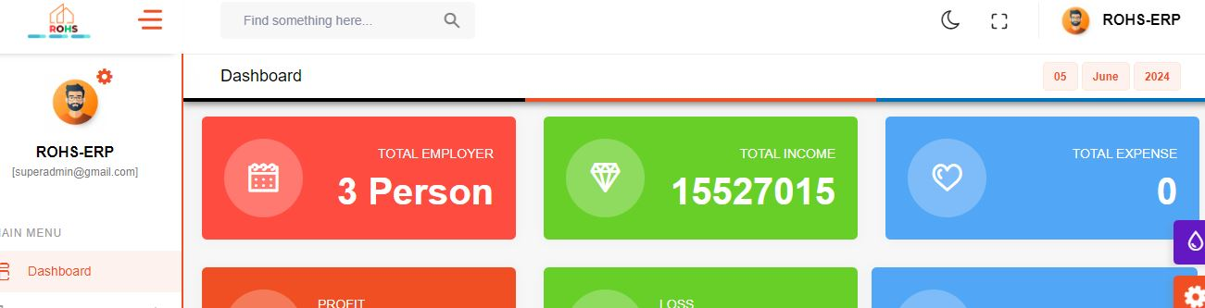

**Chart Of Account**

* Chart of Account menu click than chart of account page show than left side COA folder click than Head Name show and head name click right side form show

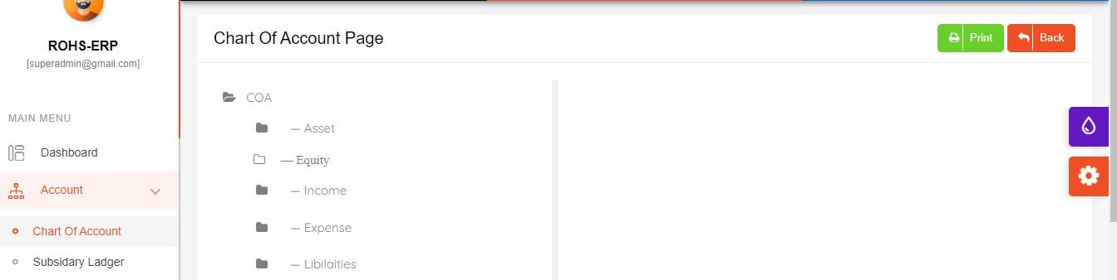

HeadName

**Ladger Create show**

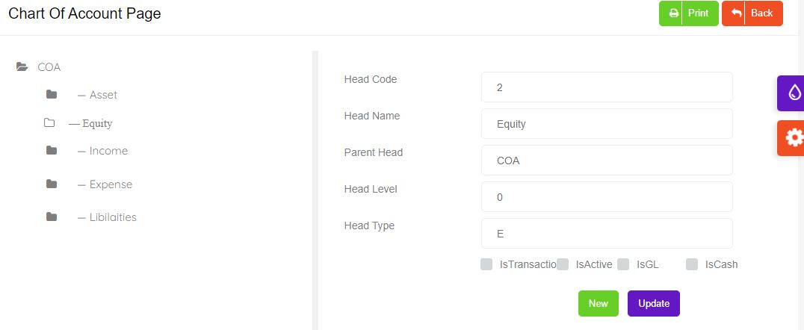

* New button click than new asset page will be shown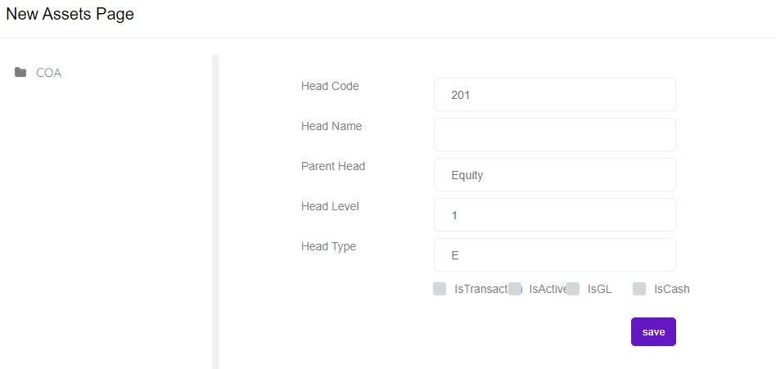
* This form a Head Name field Head name data Entry and is Cash check box show kore save button click. Then it will be saved.

**Subsidary Ladger**

* If you click on the "Subsidiary Ledger" menu, the "Create Subsidiary Ledger" page will be displayed.

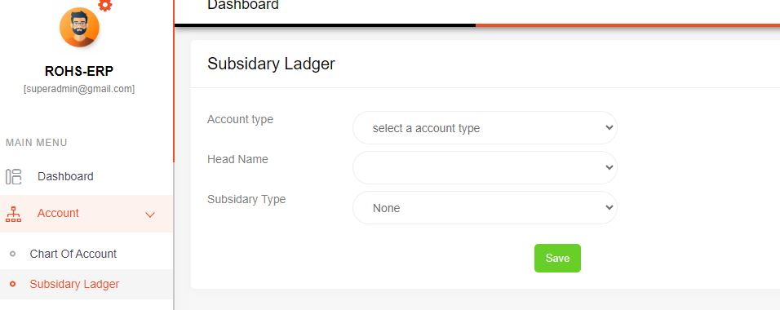

* From the Subsidiary Ledger form, when you select the account type, the head name will be displayed. Then, you can select the head name, choose the subsidiary type, and click the save button to save the data.

**Opening Balance Page**

* If you click on "Opening Balance" in the menu, the "Opening Balance Setup" page will be displayed show.

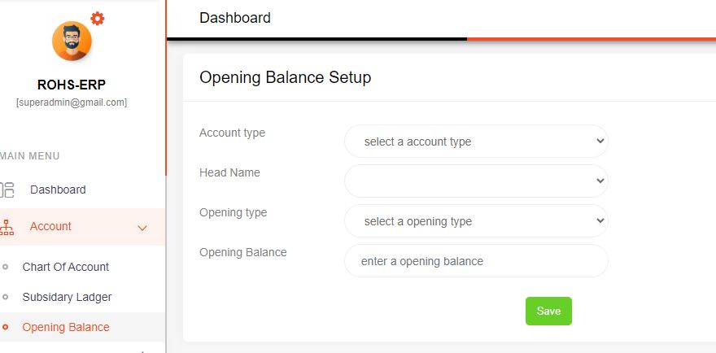

* On the Opening Balance Setup page, when you select the account type, the head name will be displayed. Then, choose the opening type, enter data in the opening balance input field, and click the save button to save the data.

**Debit Voucher Create Page**

* If you click on "Debit Voucher" from the menu, the "Create Debit Voucher" page will be displayed.

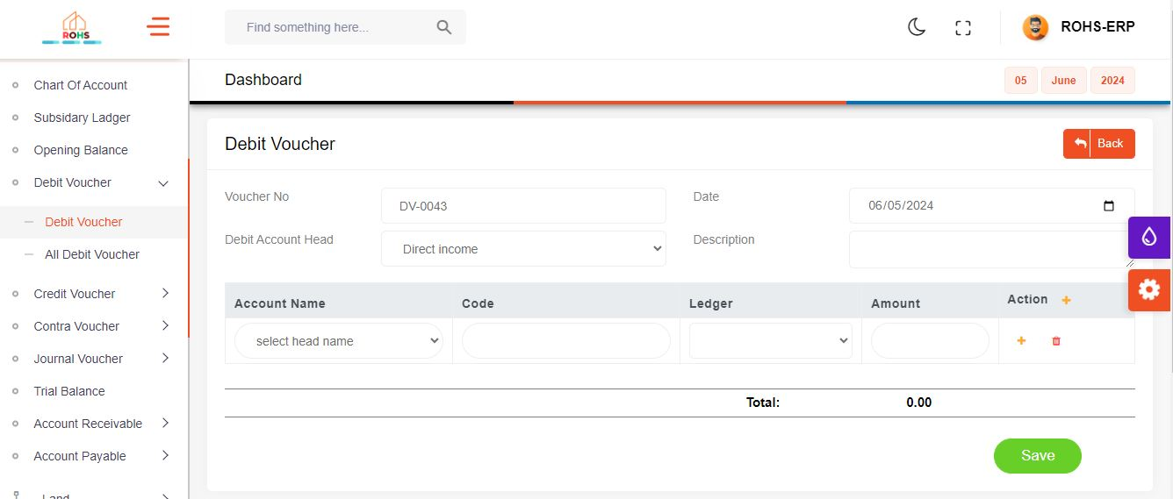

* In the Create Debit Voucher form, select the debit account head and enter data in the description field. When you select the account name, the head code and ledger name will be automatically displayed. Enter the value in the amount field and click the save button to save the data.

**All Debit Voucher**

* If you click on "All Debit Voucher" from the menu, the "All Debit Voucher List " page will be displayed.

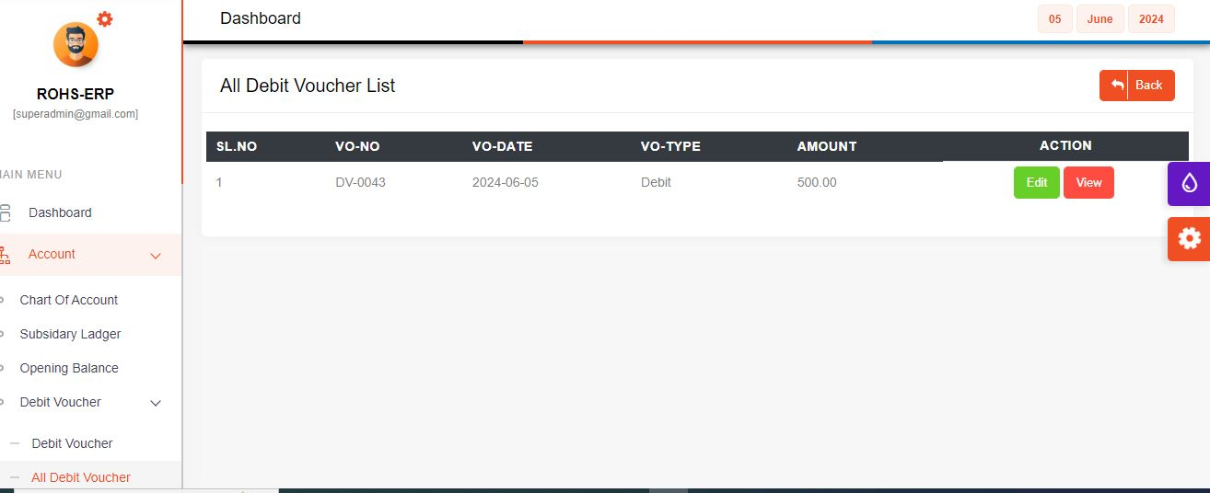

**Credit Voucher Page**

* If you click on "Credit Voucher" from the menu, the "Create Credit Voucher" page will be displayed.

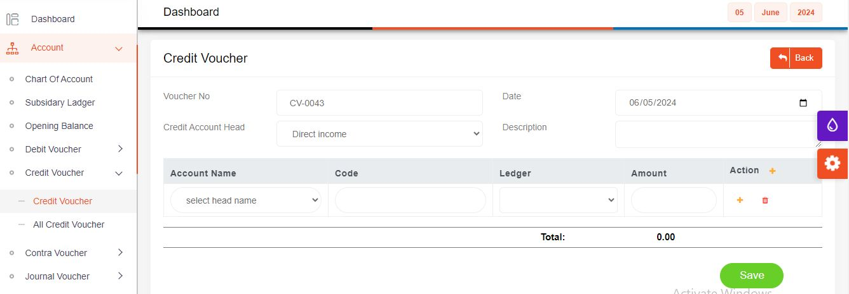

* In the Create Credit Voucher form, select the Credit account head and enter data in the description field. When you select the account name, the head code and ledger name will be automatically displayed. Enter the value in the amount field and click the save button to save the data.

**All Credit Voucher List**

* If you click on "All Credit Voucher" from the menu, the "All Credit Voucher List " page will be displayed.

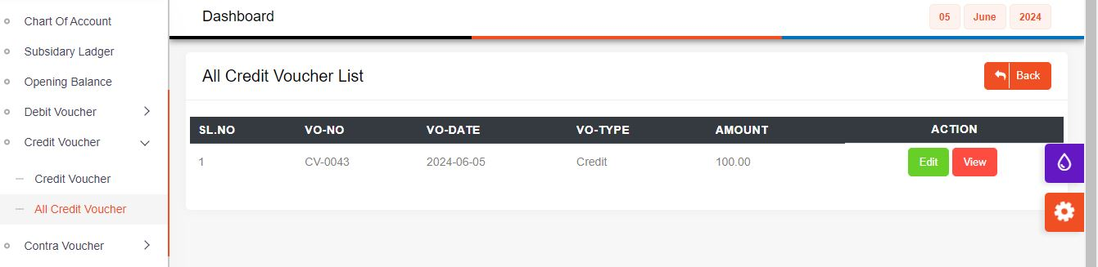

Contra Voucher Page

* If you click on "Contra Voucher" from the menu, the "Create Contra Voucher" page will be displayed.

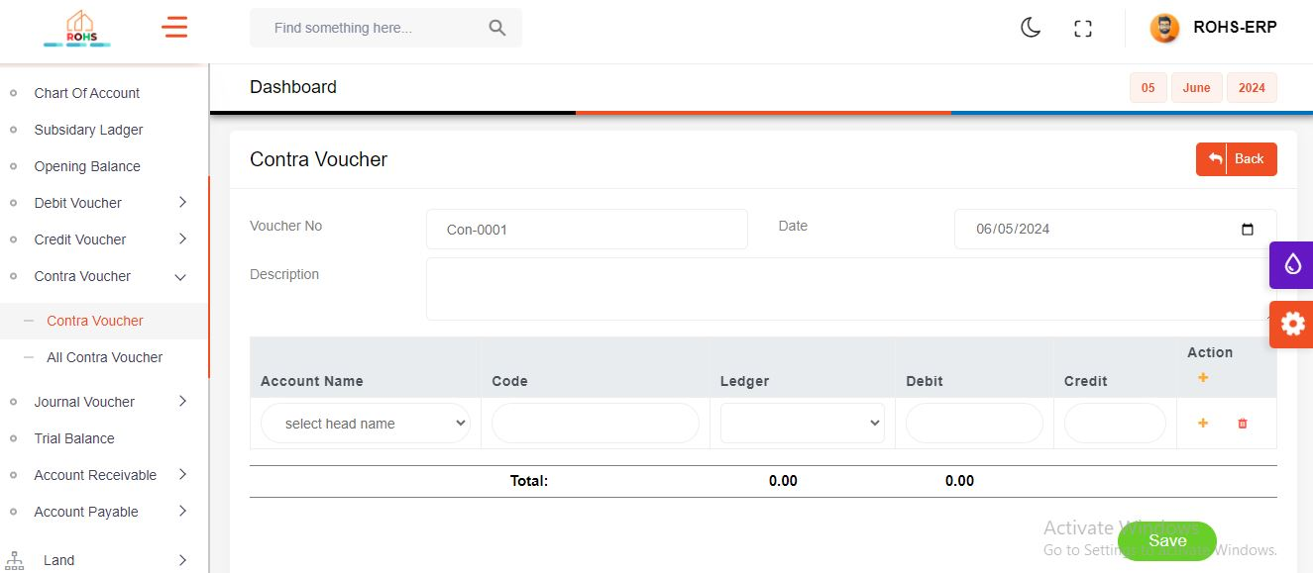

* In the Create Contra Voucher form, and enter data in the description field. When you select the account name, the head code and ledger name will be automatically displayed. Enter the value in the debit and credit field and click the save button to save the data.

**All Contra Voucher List**

* If you click on "All Contra Voucher" from the menu, the "All Contra Voucher List " page will be displayed.

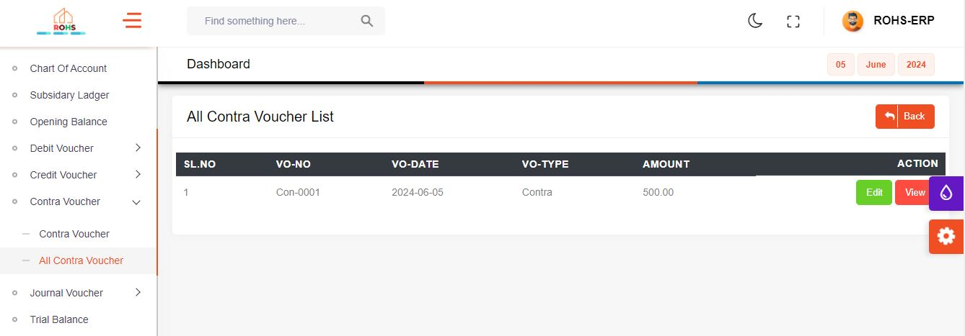

Journal Voucher Page

* If you click on "Journal Voucher" from the menu, the "Create Journal Voucher" page will be displayed.

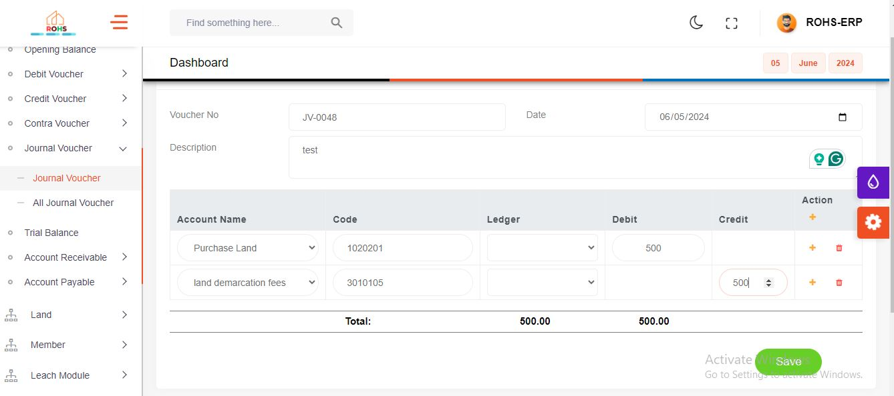

* In the Create Journal Voucher form, and enter data in the description field. When you select the account name, the head code and ledger name will be automatically displayed. Enter the value in the debit and credit field and click the save button to save the data.

All Journal Voucher List

* If you click on "All Journal Voucher" from the menu, the "All Journal Voucher List " page will be displayed.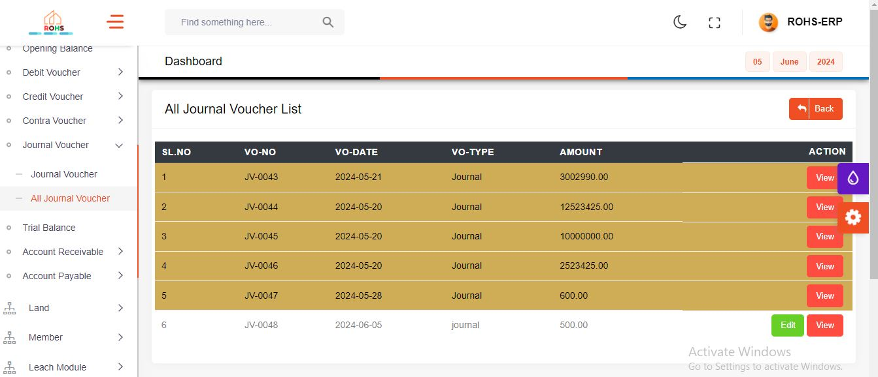

Land Payment Page

* If you click on "Land Payment" from the menu, the " Land Payment Received Index" page will be displayed.

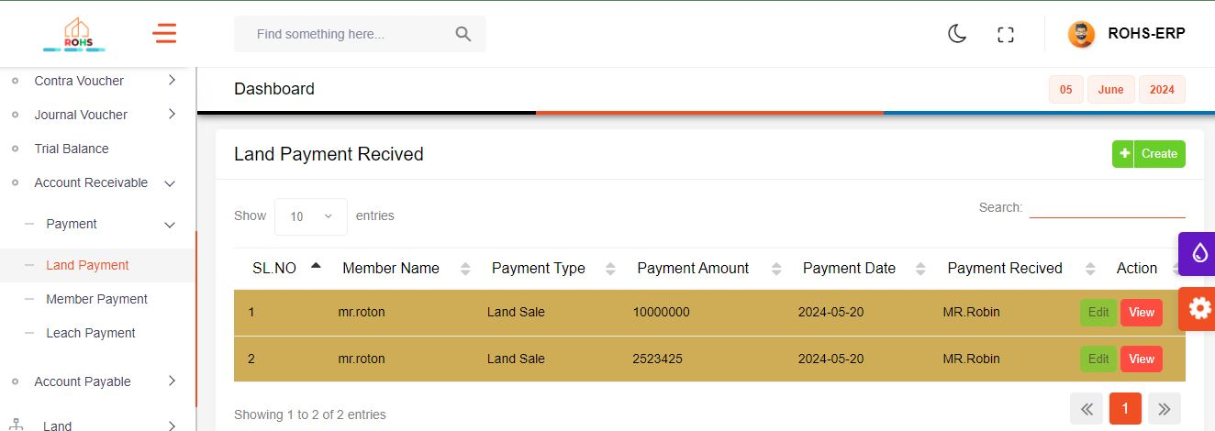

* 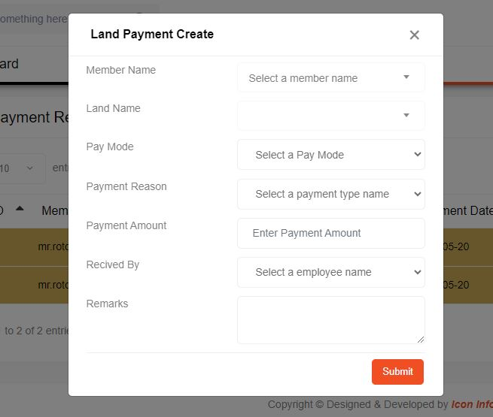When you click the create button on this page, a modal will open.
* Select the member name, and the land associated with this member will be automatically displayed. Then, select the payment mode, payment reason, enter the payment amount, select received by, enter remarks, and click the submit button to save the data.

Member Payment

* If you click on "Member Payment" from the menu, the " member fee payment Received index " page will be displayed.

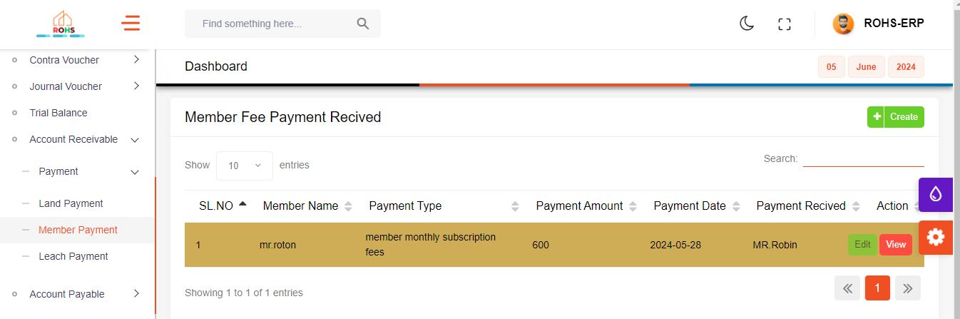

* When you click the create button on this page, a modal will open.

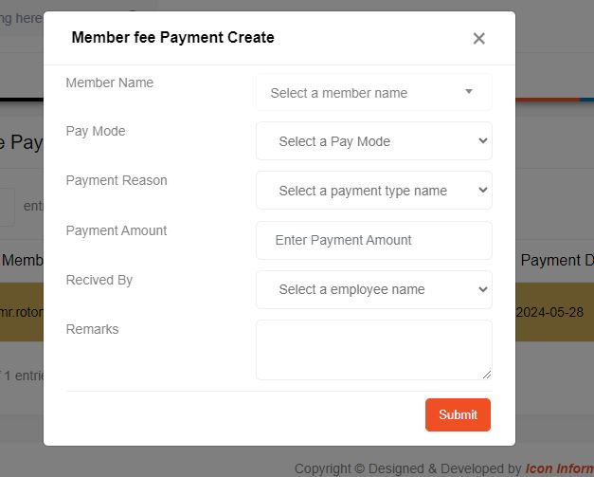

* Select the member name, Then, select the payment mode, payment reason, enter the payment amount, select received by, enter remarks, and click the submit button to save the data.

Leach Payment Page

* If you click on "Leach Payment" from the menu, the " Leach payment Received index " page will be displayed.

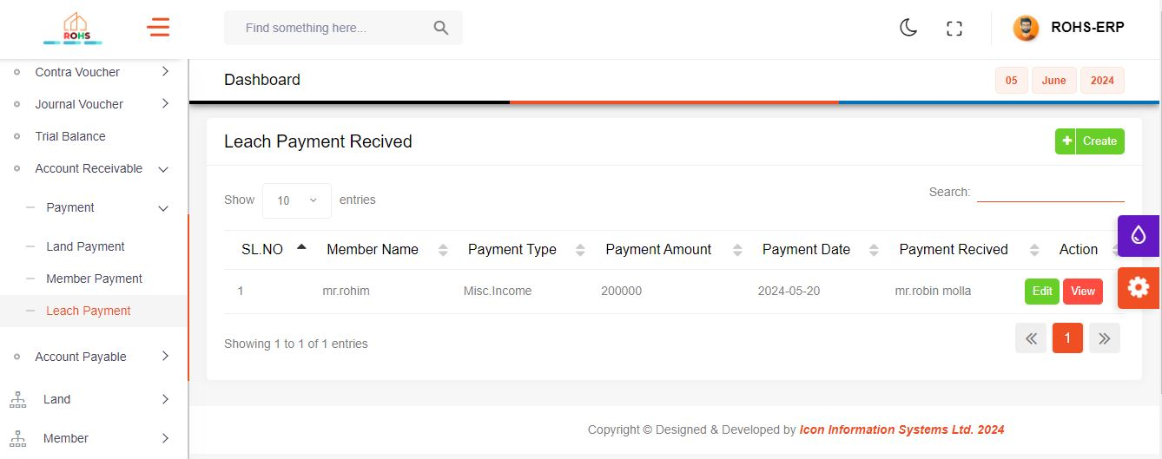

* When you click the create button on this page, a modal will open.

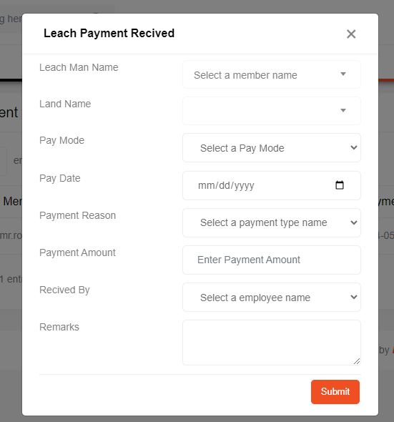

* Select the leach man name, Then select the land name, Then, select the payment mode, payment reason, enter the payment amount, select received by, enter remarks, and click the submit button to save the data.

Association Payment for Media

* If you click on "Payment" from the menu, the " Association Payment For supplier" page will be displayed.

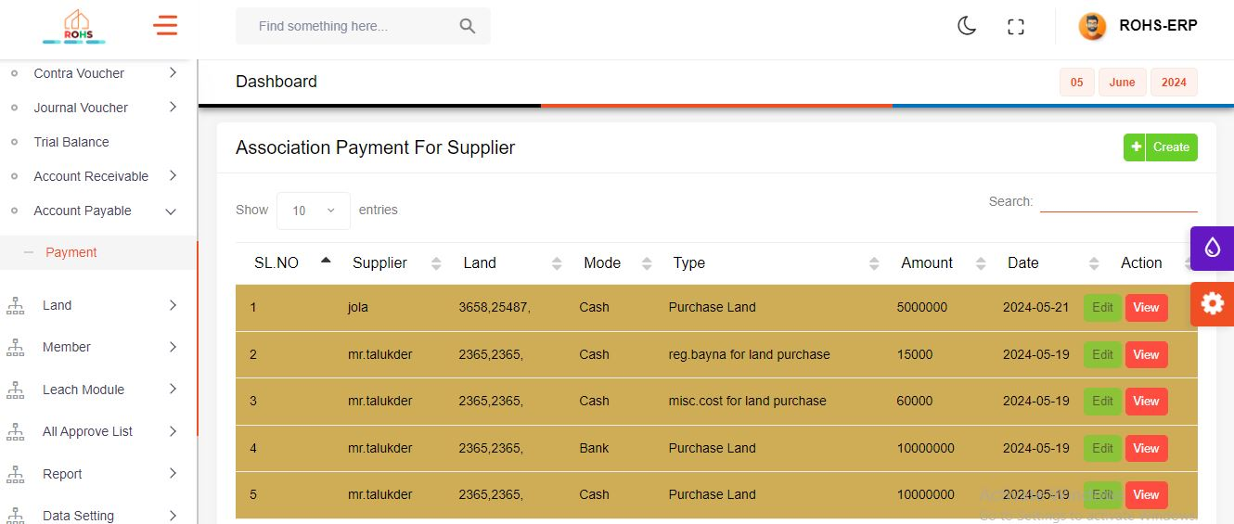

* When you click the create button on this page, a modal will open.

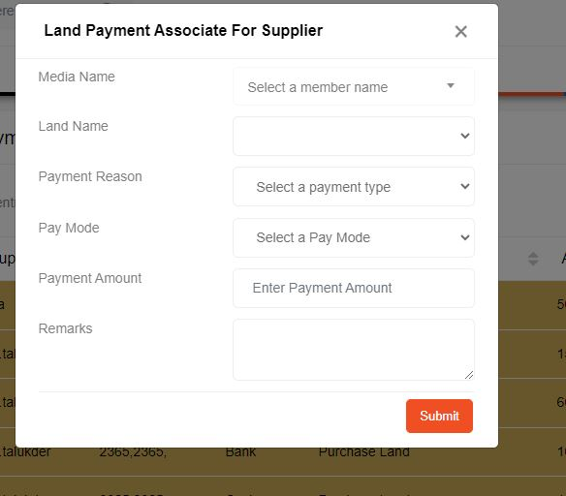

* Select the media name, Then select the land name, Then, select the payment mode, payment reason, enter the payment amount, enter remarks, and click the submit button to save the data.

**Supplier Land Owner Page**

* If you click on "Supplier (Land Owner) Info" from the menu, the " All Supplier List" page will be displayed.

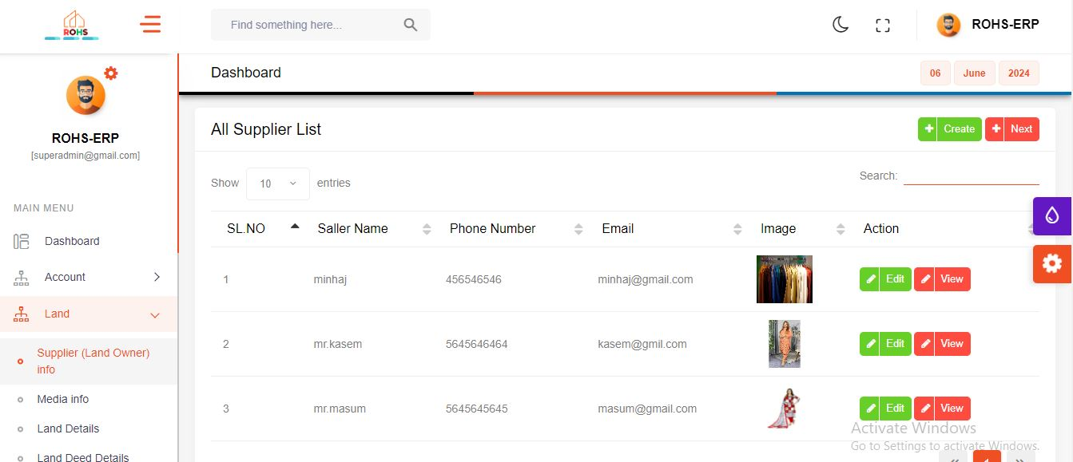

* When you click the create button on this page, a modal will open.

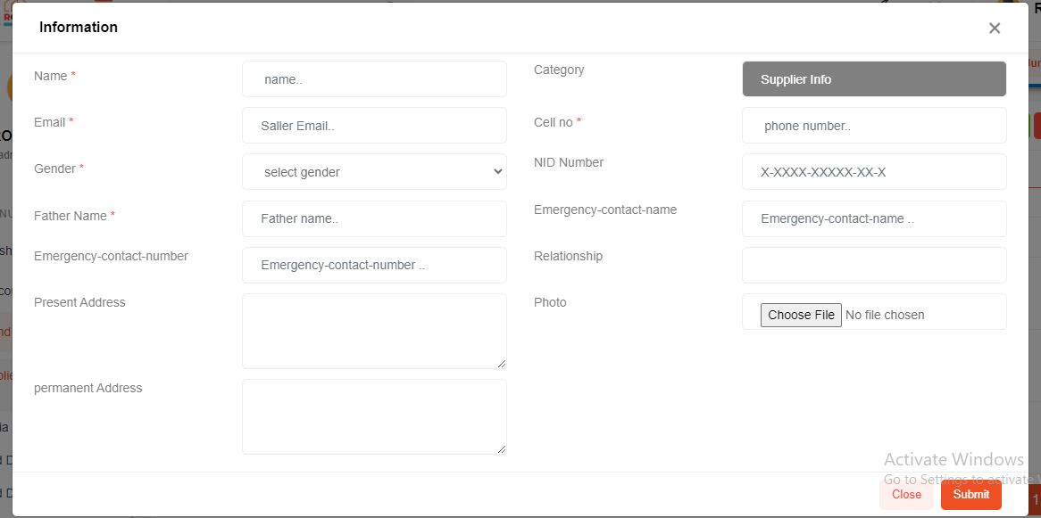

* When this form is submitted, all fields will be inserted as values, and upon clicking the submit button, the land owner information data will be saved

**Media Info Page**

* If you click on "Media Info" from the menu, the " All Media List" page will be displayed.

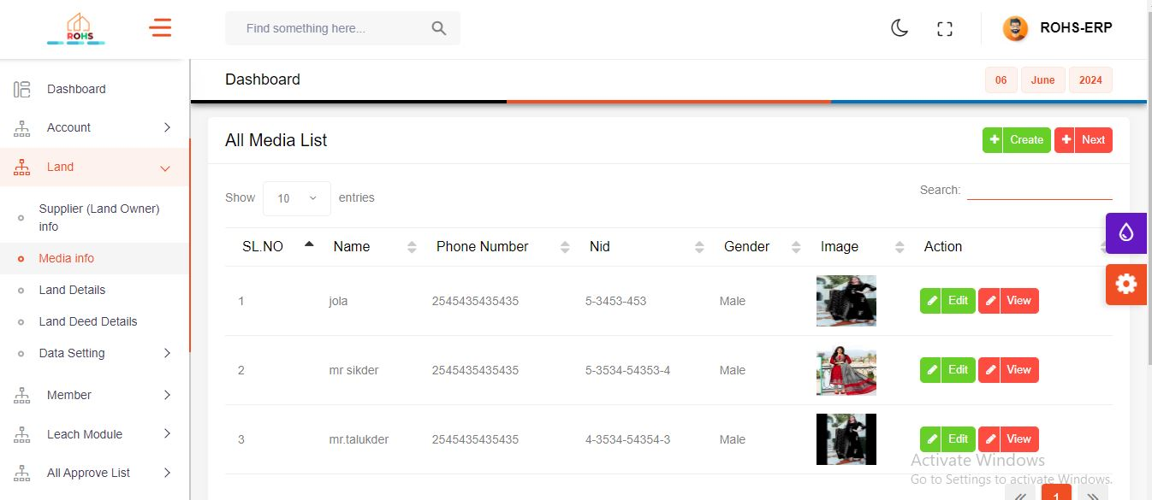

* When you click the create button on this page, a modal will open.

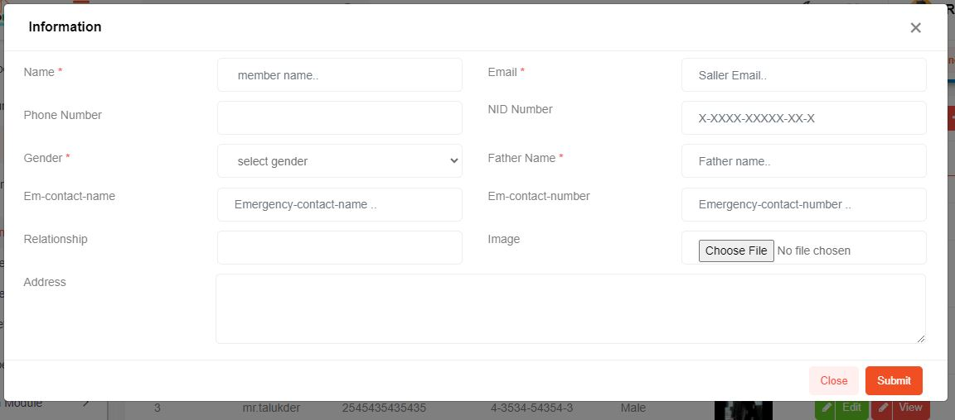

* When this form is submitted, all fields will be inserted as values, and upon clicking the submit button, the Media Info data will be saved

**Land Details Page**

* If you click on "Land Details" from the menu, the " Land Details" page will be displayed.

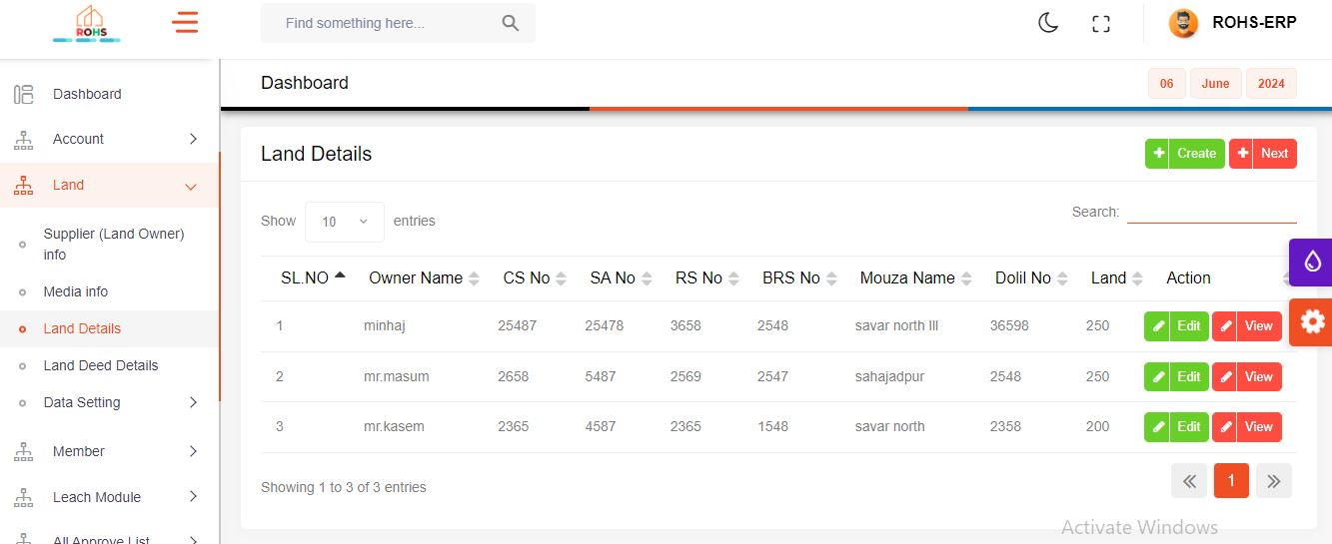

* When you click the create button on this page, a modal will open.

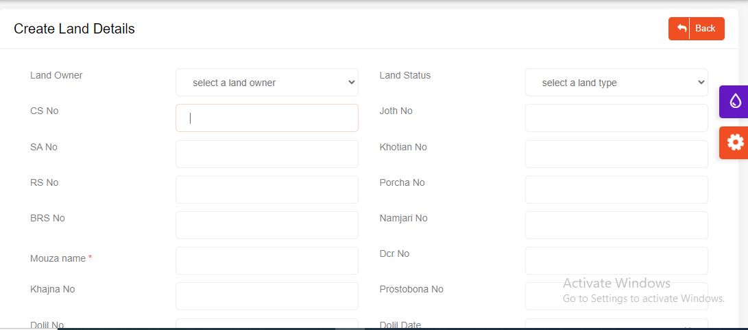

* When this form is submitted, all fields will be inserted as values, and upon clicking the submit button, the Land Details data will be saved

**Land Deed Details**

* If you click on "Land Deed Details" from the menu, the " Deed Details" page will be displayed.

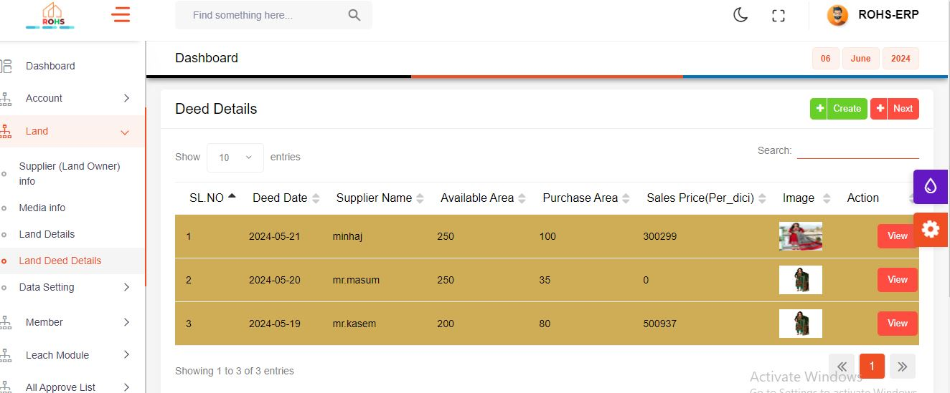

* When you click the create button on this page, a modal will open.

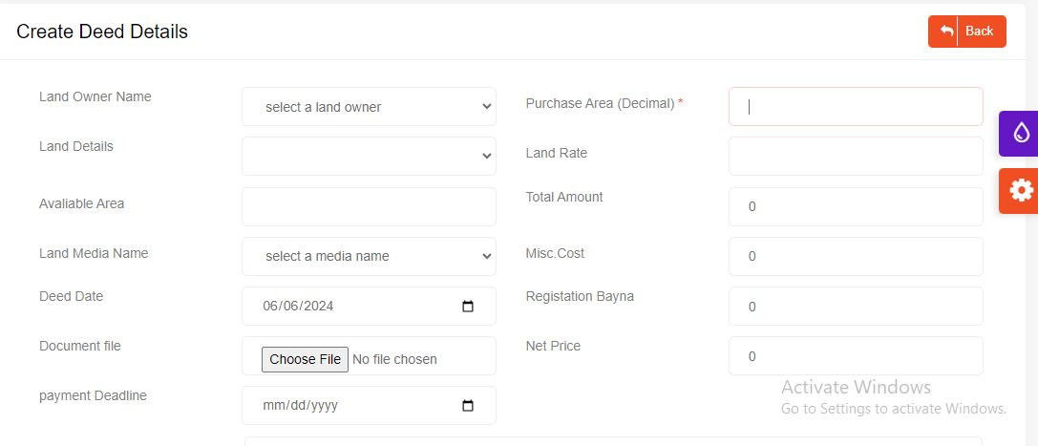

* When this form is submitted, all fields will be inserted as values, and upon clicking the submit button, the Land Deed Details data will be saved

**Land Price Circulation**

* If you click on "Land Price Circulation" from the menu, the "Land Price Circulation" page will be displayed.

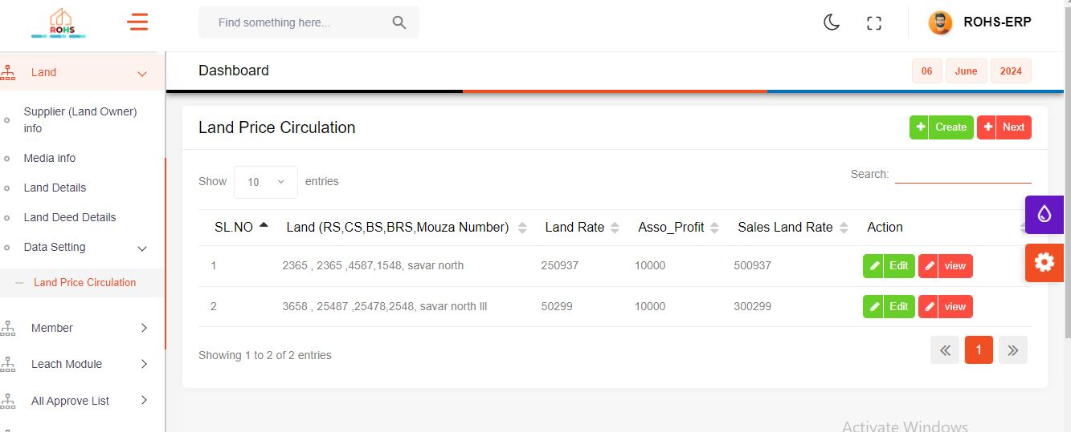

* When you click the create button on this page, a modal will open.

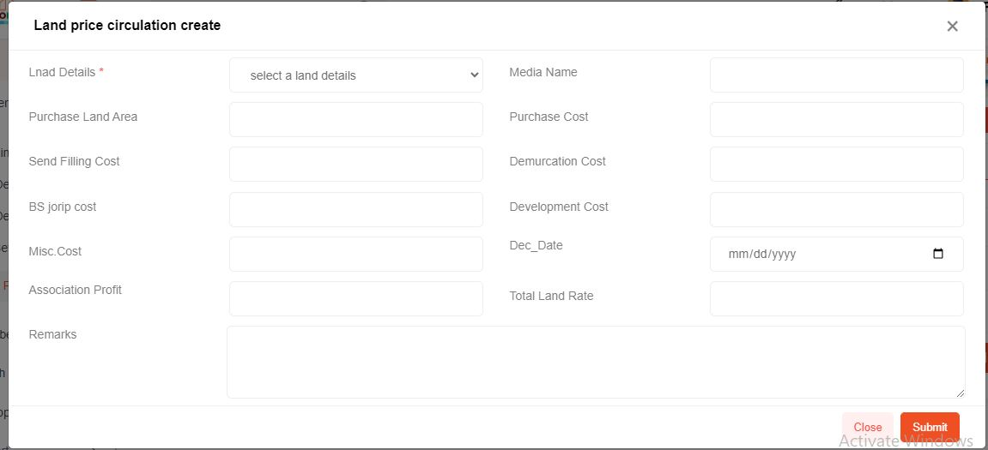

* When this form is submitted, all fields will be inserted as values, and upon clicking the submit button, the Land price circulation data will be saved

**Member Details**

* If you click on "Member Details" from the menu, the "All Member List" page will be displayed.

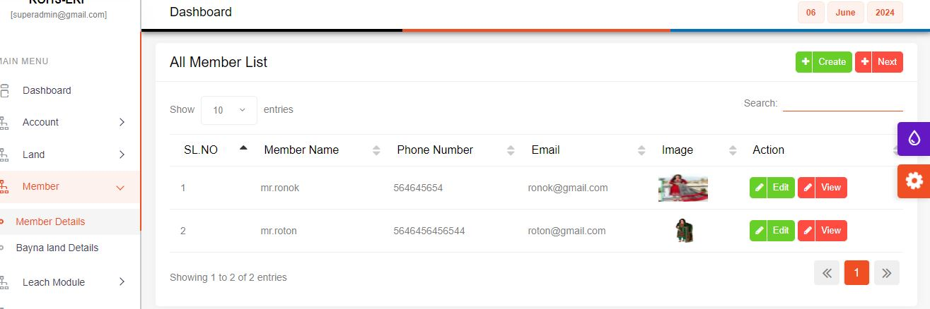

* 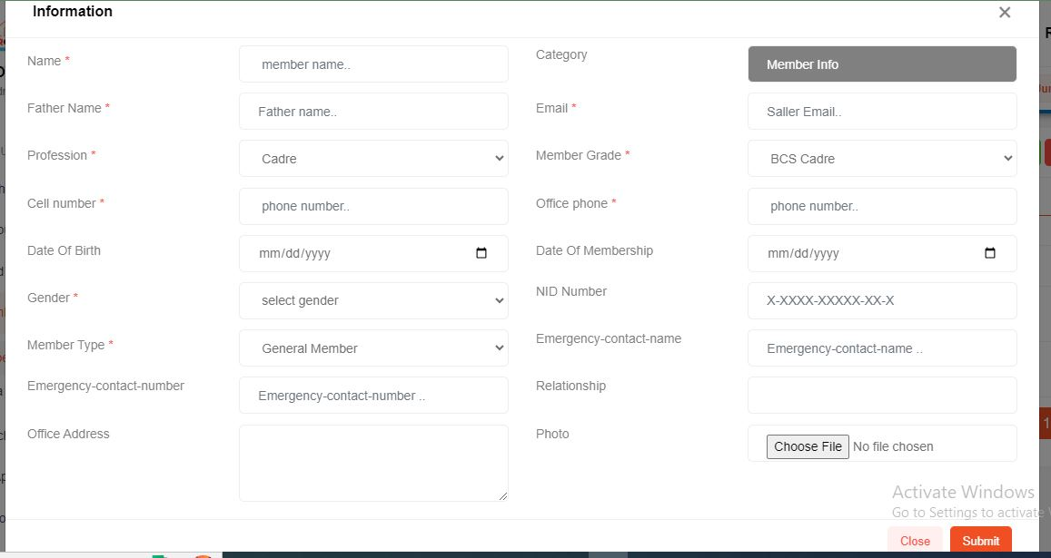When you click the create button on this page, a modal will open.
* When this form is submitted, all fields will be inserted as values, and upon clicking the submit button, the Member Details data will be saved

**Bayna Land Details**

* If you click on " Bayna land Details" from the menu, the "Member Bayna Land Details" page will be displayed.

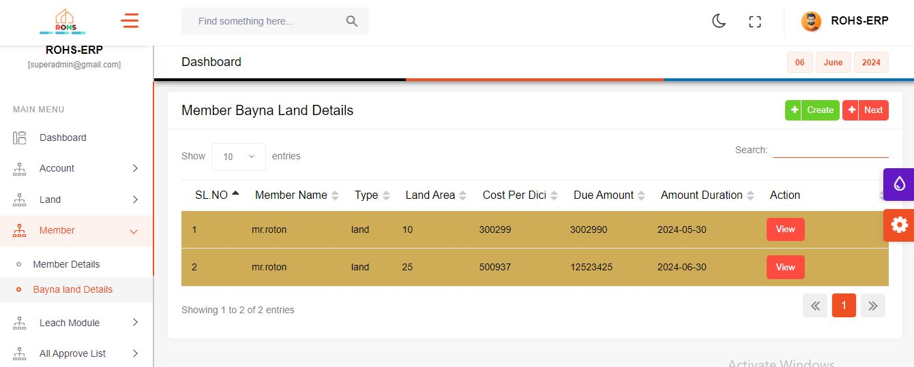

* When you click the create button on this page, a modal will open.

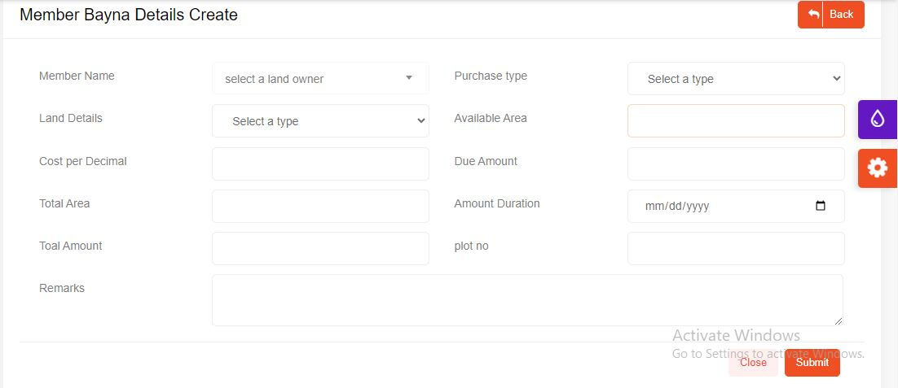

* When this form is submitted, all fields will be inserted as values, and upon clicking the submit button, the Member Bayna Land Details data will be saved

**Leach Man Info**

* If you click on " Leach Man Info" from the menu, the "Leach Man Information" page will be displayed.

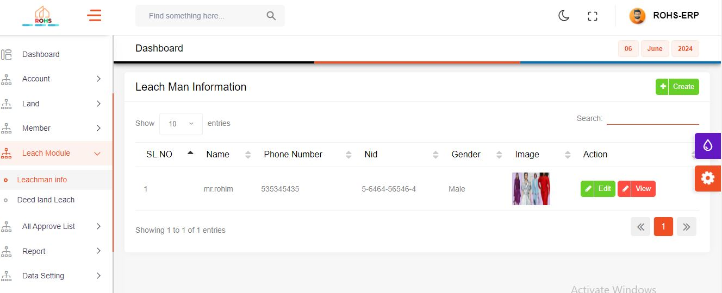

* When you click the create button on this page, a modal will open.

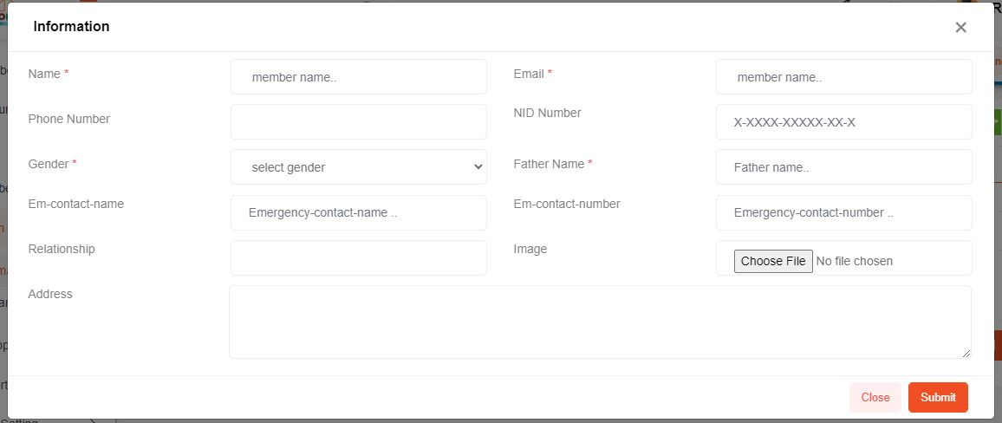

* When this form is submitted, all fields will be inserted as values, and upon clicking the submit button, the Leach Man Information data will be saved

**Deed Land Leach Page**

* If you click on " Deed Land Leach" from the menu, the "Leach Land Information" page will be displayed.

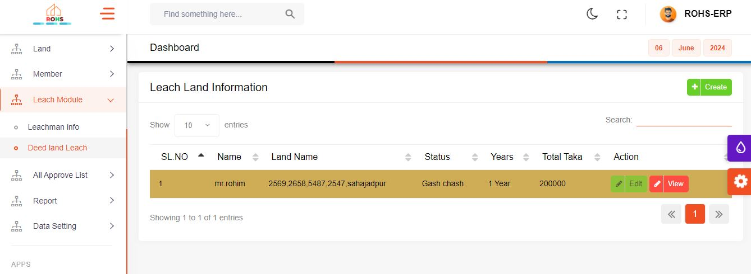

* When you click the create button on this page, a modal will open.

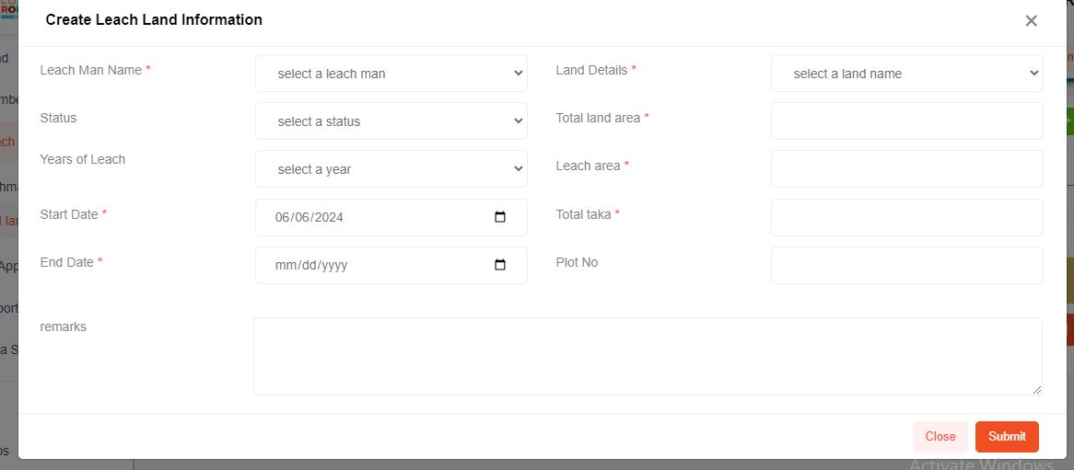

* When this form is submitted, all fields will be inserted as values, and upon clicking the submit button, the Leach Land Information data will be saved

**Voucher Approve Page**

* 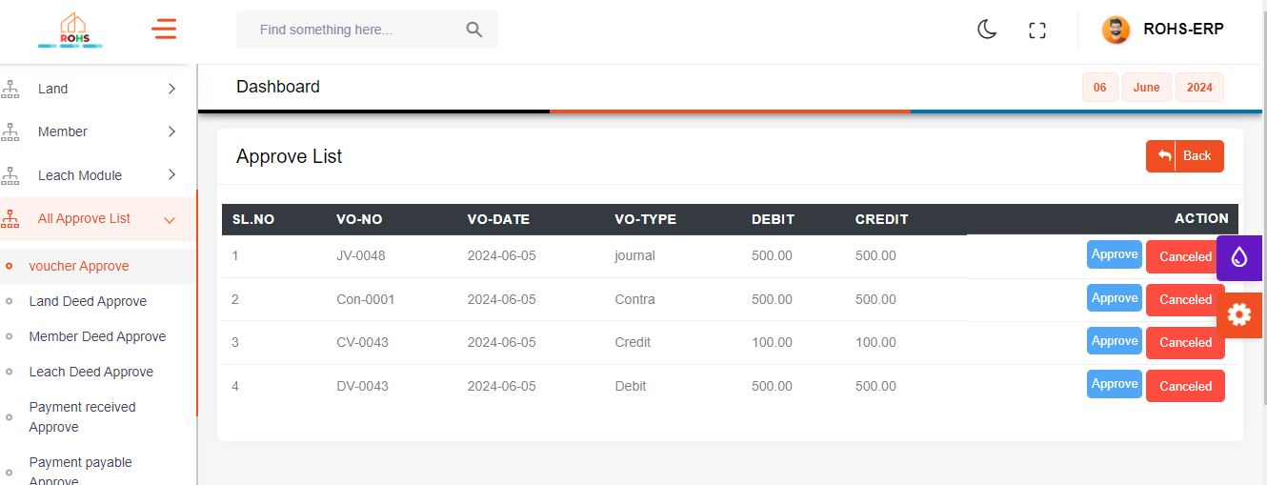If you click on " Voucher Approve" from the menu, the "Approve List" page will be displayed.
* When the approve button on this page is clicked, the voucher will be approved, and if canceled, the voucher will be canceled.

**Land Deed Approve**

* If you click on " Land Deed Approve" from the menu, the "Land Deed Approve List" page will be displayed

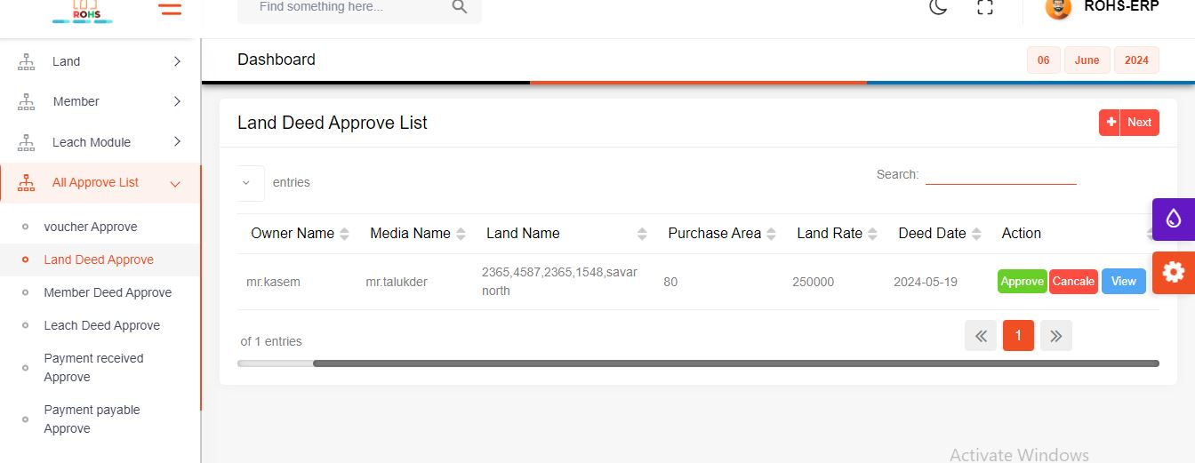

* When the approve button on this page is clicked, the voucher will be approved, and if canceled, the voucher will be canceled.

**Member Deed Approve**

* If you click on " Member Deed Approve" from the menu, the "Member Bayna Approve List" page will be displayed

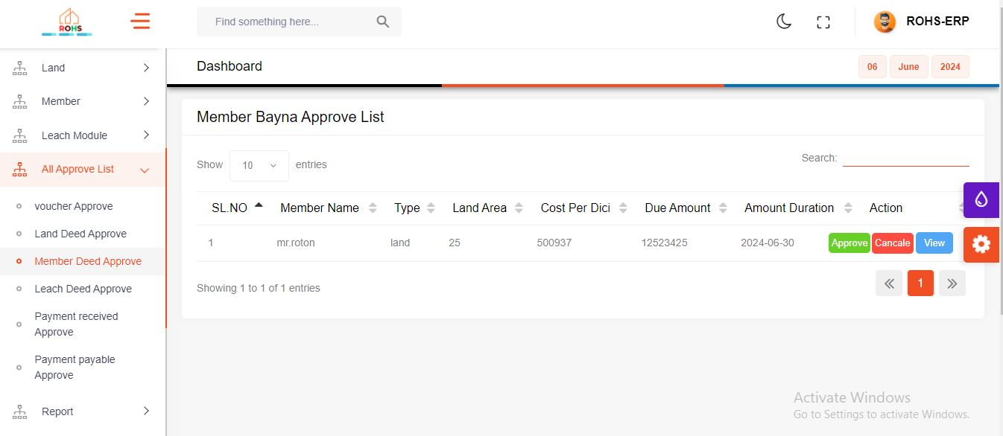

* When the approve button on this page is clicked, the voucher will be approved, and if canceled, the voucher will be canceled.

**Leach Deed Approve Page**

* If you click on " Leach Deed Approve" from the menu, the "All Leach Land Approve List" page will be displayed

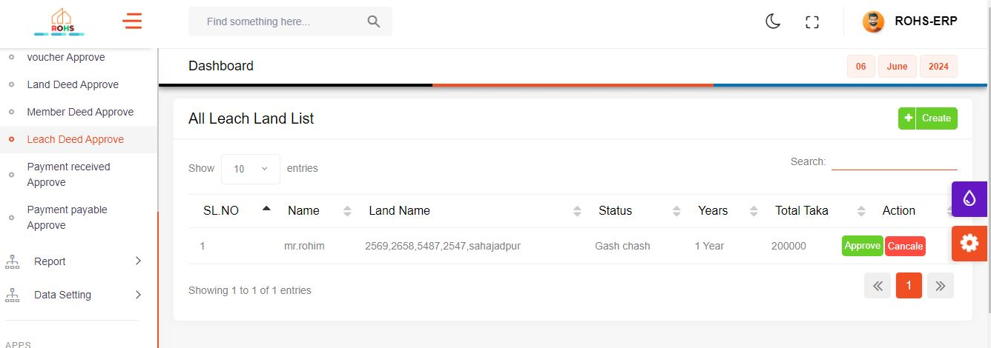

* When the approve button on this page is clicked, the voucher will be approved, and if canceled, the voucher will be canceled.

**Payment Received Approved Page**

* If you click on " Payment Received Approve" from the menu, the "Payment Approve List" page will be displayed

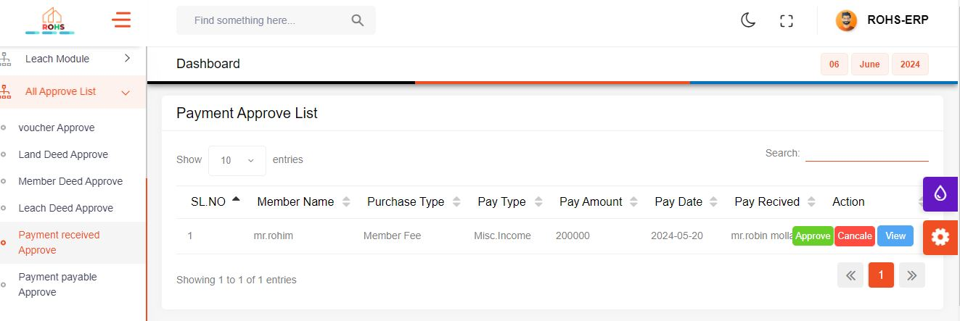

* When the approve button on this page is clicked, the voucher will be approved, and if canceled, the voucher will be canceled.

**Payment Payable Approve List**

* If you click on " Payment Payable Approve" from the menu, the "Supplier Payment Approve For Land Purchase List" page will be displayed

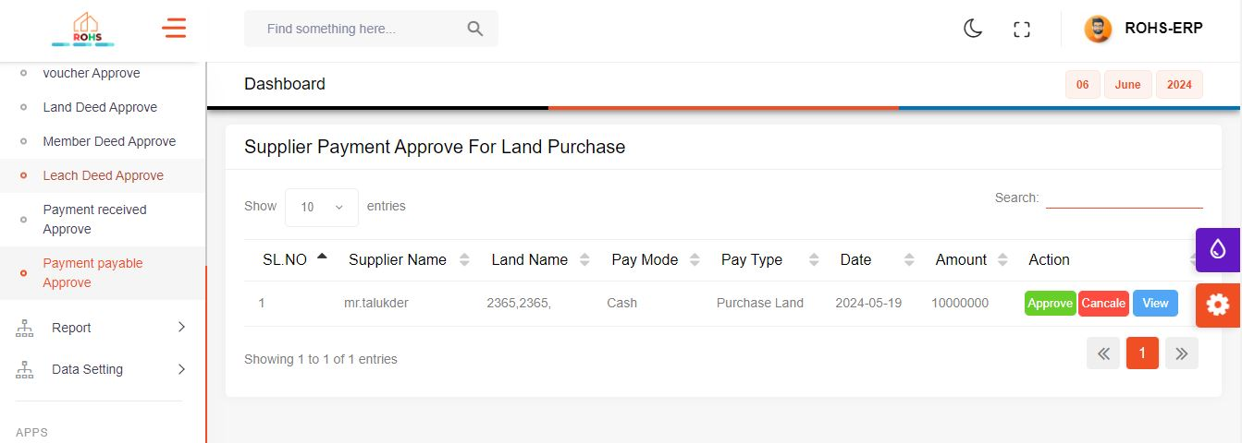

* When the approve button on this page is clicked, the voucher will be approved, and if canceled, the voucher will be canceled.

**Ledger Wise Transection**

* If you click on " Ledger Wise Tranjection " from the menu, the "Ledger Wise Tranjection Page" page will be displayed

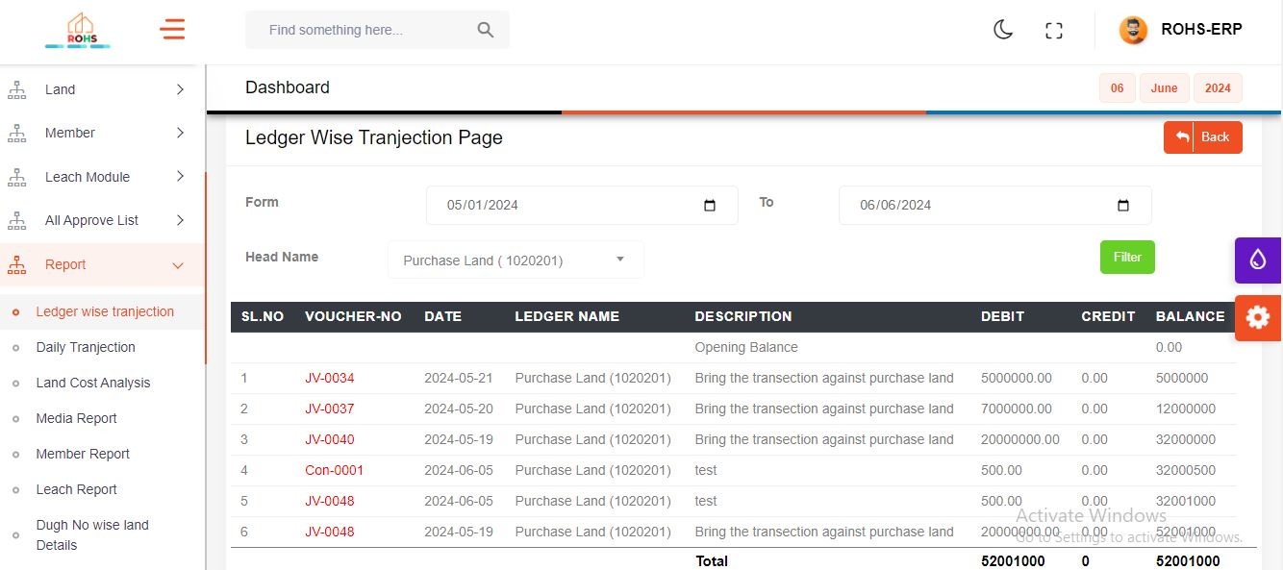

* On this page, you can view the report for a specific head name within the date range from "from date" to "to date".

**Daily Transection Page**

* If you click on " Daily Tranjection " from the menu, the "Daily Transection Report " page will be displayed

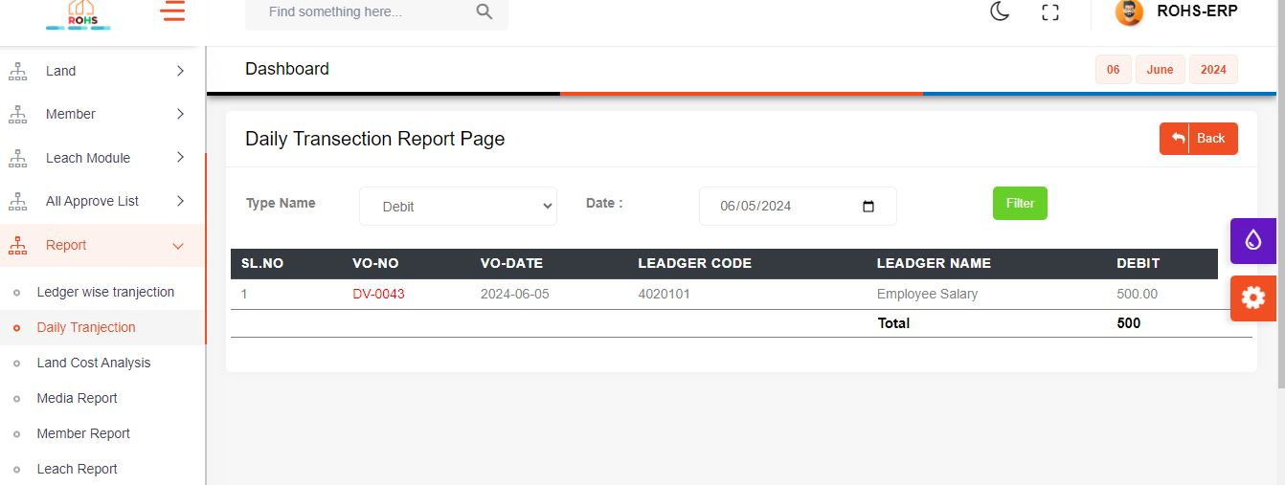

* On this page, you can view the report for a Select a Type Name Then data showing

**Land Cost Analysis**

* If you click on " Land Cost Analysis " from the menu, the "Land Cost Analysis Report " page will be displayed

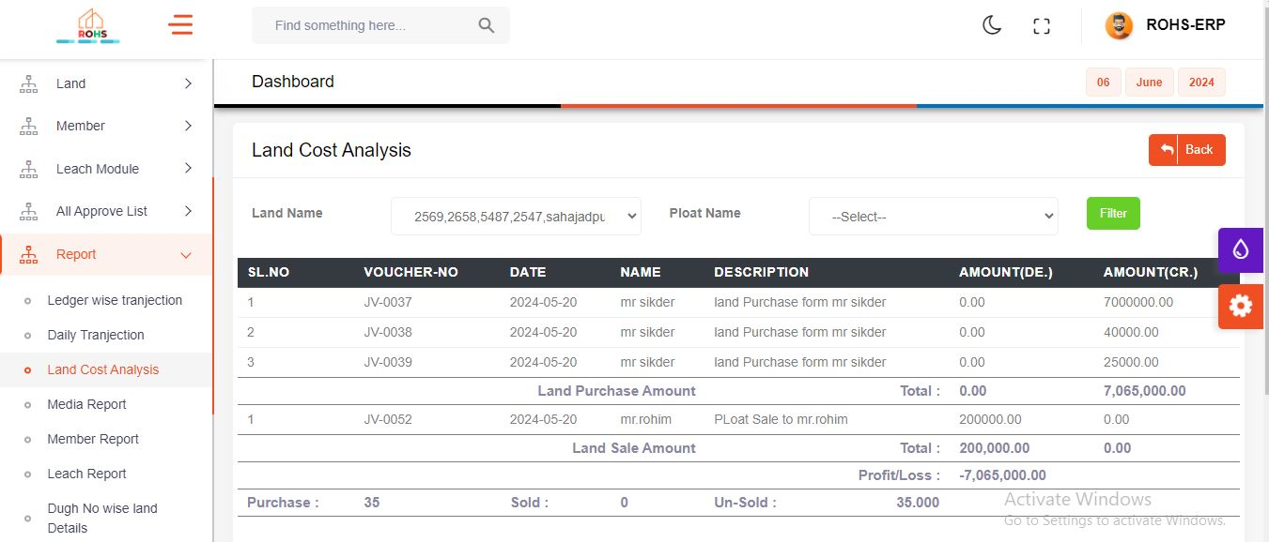

* Clicking on a specific land will show all the data for that land.

**Media Report Page**

* If you click on " Media Report " from the menu, the "Supplier Wise Report " page will be displayed

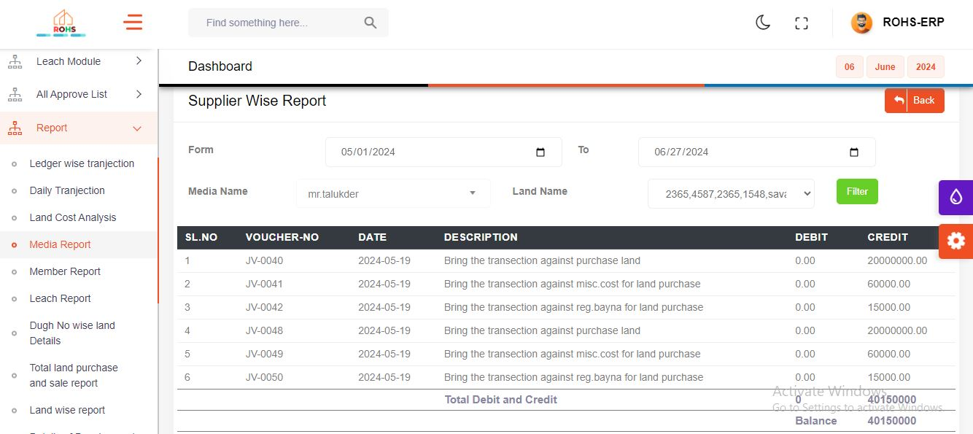

* On this page, you can view the report for a specific Media name select then media name against land name show within the date range from "from date" to "to date".

**Member Report Page**

* If you click on " Member Report " from the menu, the "Member Wise Report " page will be displayed

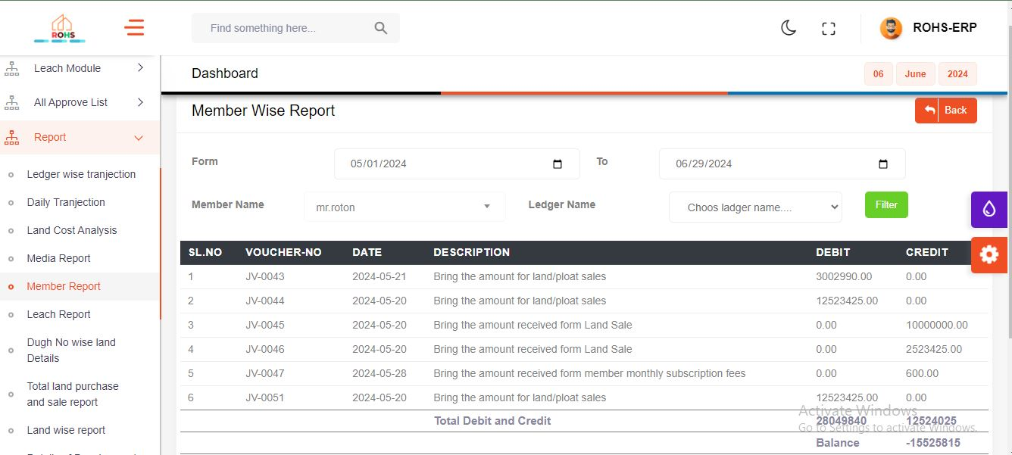

* On this page, you can view the report for a specific Member name select within the date range from "from date" to "to date".

**Land Leach Report Page**

* If you click on " Leach Report " from the menu, the "Leach Wise Report " page will be displayed

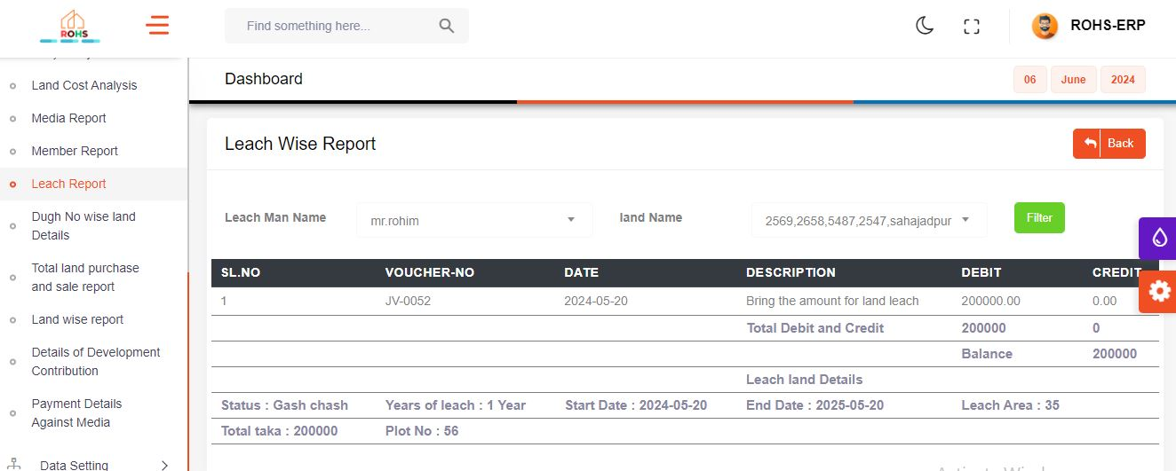

* On this page, select a specific leach man to display the land names associated with that leach man. After selecting a land name and clicking the filter button, the data will be shown.

**Dugh No Wise Land Details**

* If you click on " Dugh No Wise Land Details " from the menu, the "Dugh No Wise Land Details" page will be displayed

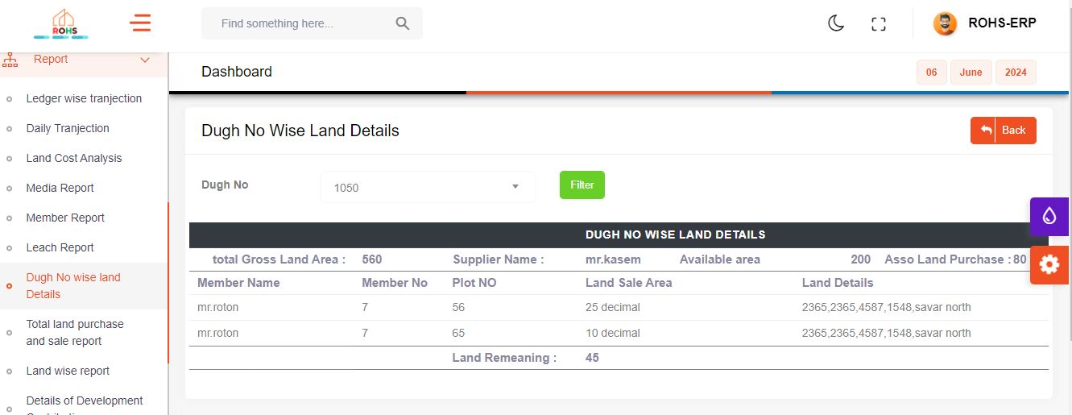

* Clicking on a specific dugh number will show all the data associated with that dugh.

**Total Land Purchase And Sale Report**

* If you click on " Total Land Purchase and sale report " from the menu, the "Total Land Purchase and Sale Report" page will be displayed

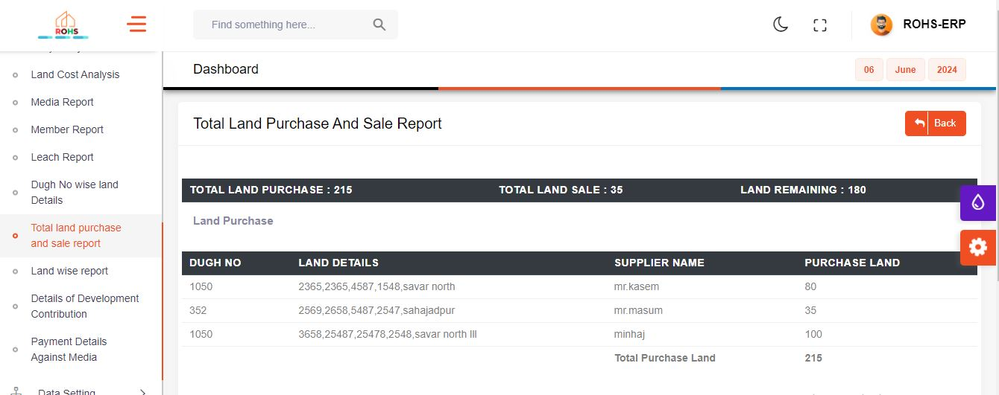

**Land Wise Report**

* If you click on " Land Wise Report" from the menu, the "Land Wise Report" page will be displayed

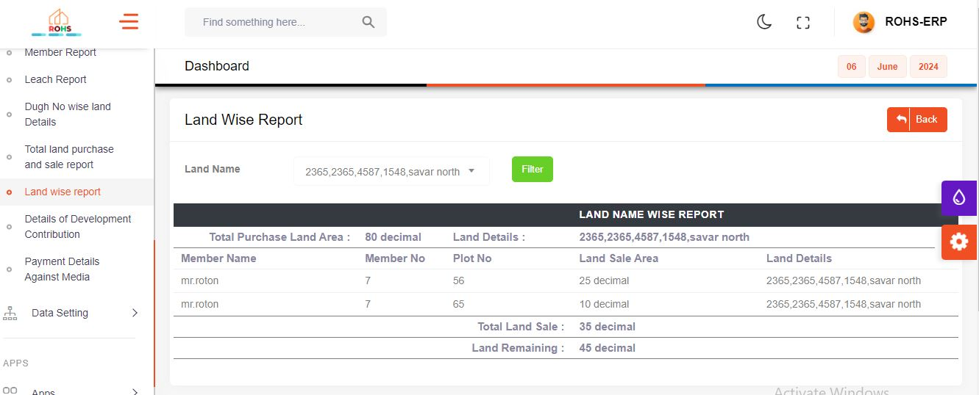

* Clicking on a specific Land Name will show all the data associated with that Land Name.

**Details Of Development Contribution Page**

* If you click on " Details of Development Contribution" from the menu, the "Details Of Development Contribution" page will be displayed

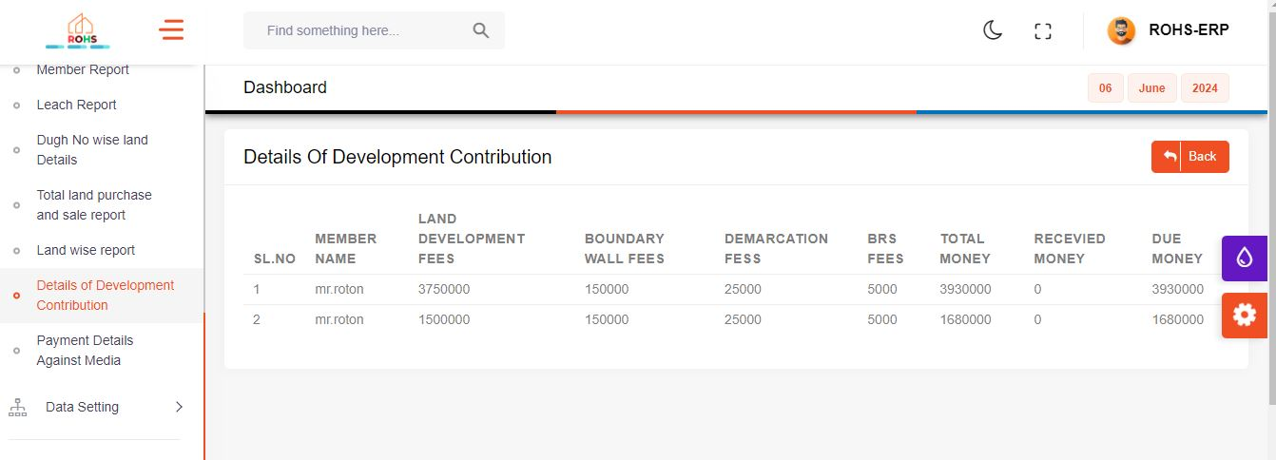

**Payment Details Against Media**

* If you click on " Payment Details Against Media" from the menu, the "Payment Details Against Media" page will be displayed

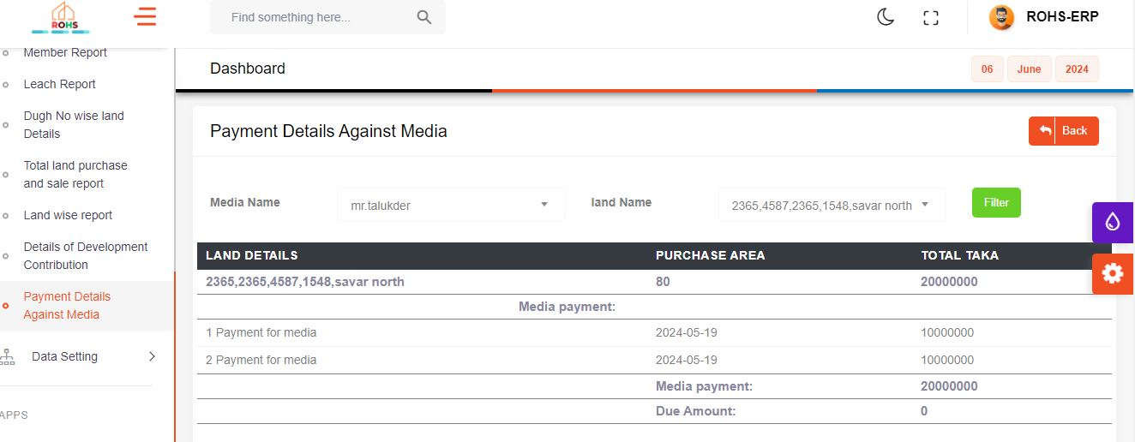

* On this page, you can view the report for a specific Media name select then media name against land name show then land name select then filter button click data show

**Employee Information Page**

* If you click on " Employee Info" from the menu, the "All Employee List" page will be displayed

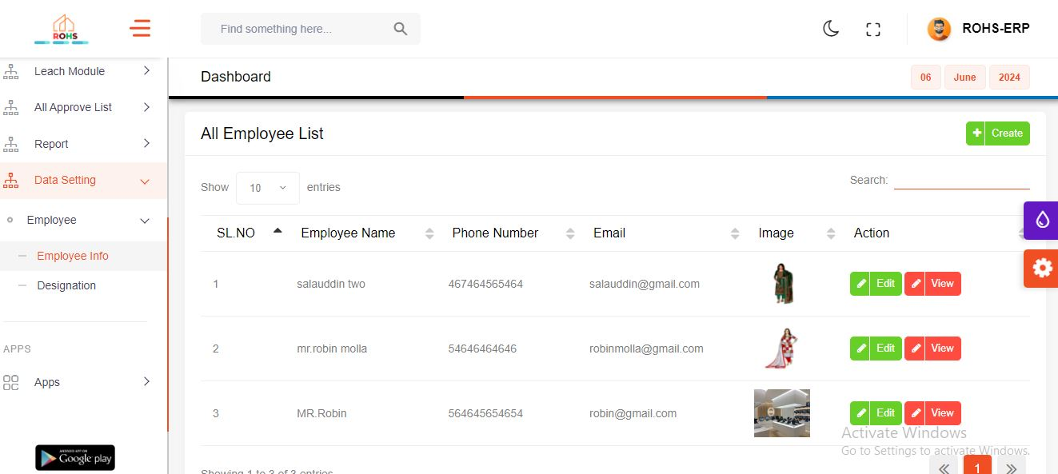

* When you click the create button on this page, a modal will open.

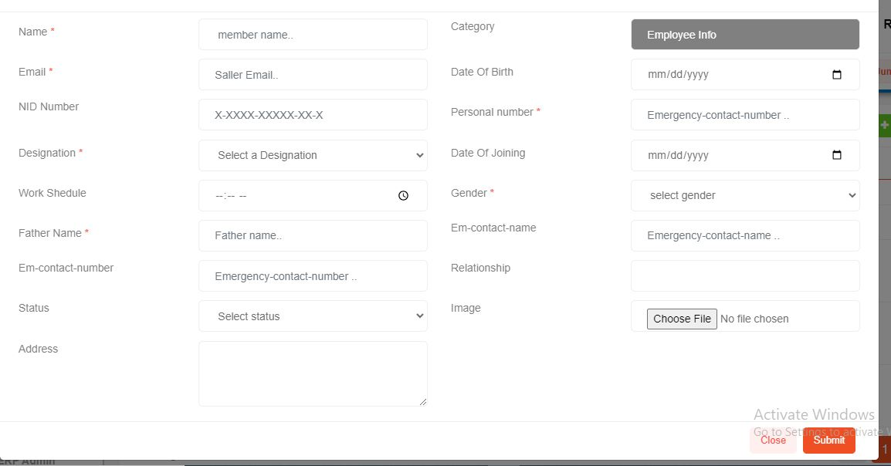

* When this form is submitted, all fields will be inserted as values, and upon clicking the submit button, the Employee Information data will be saved

**Designation Page**

* If you click on " Designation" from the menu, the "All Designation List" page will be displayed

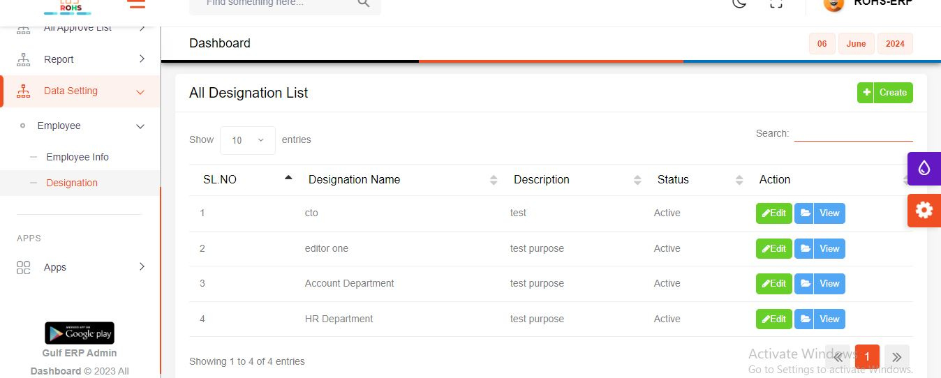

* When you click the create button on this page, a modal will open.

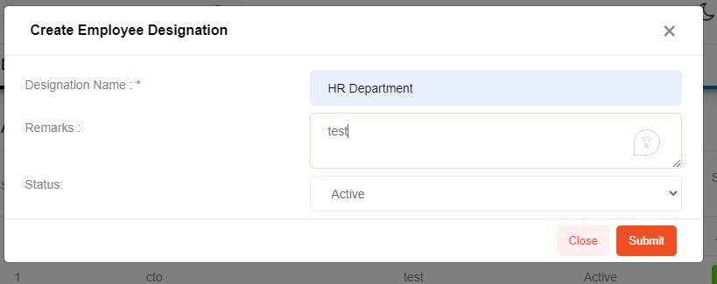

* When this form is submitted, all fields will be inserted as values, and upon clicking the submit button, the Employee Designation data will be saved

**Bank To Bank Loan**

* If you click on " Bank To Bank Loan" from the menu, the "Bank To Bank Transfer List" page will be displayed

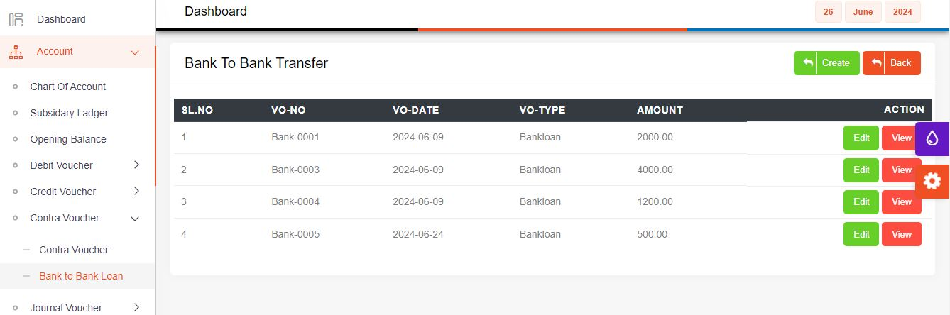

* When you click the create button on this page, will open.

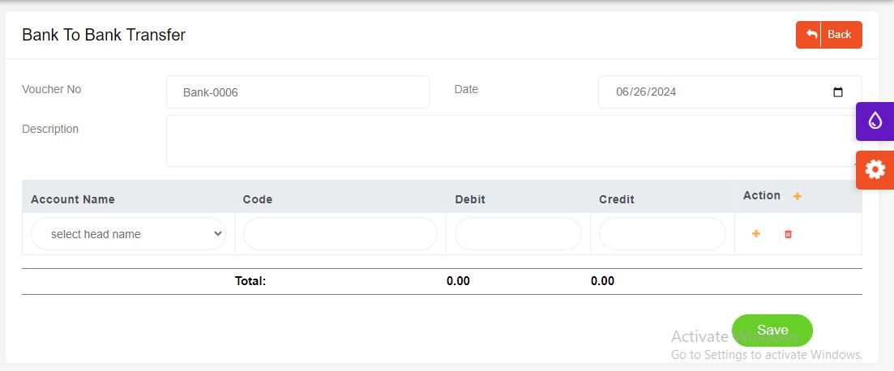

**Loan Person Info Page**

* If you click on " Loan Person Info" from the menu, the "Loan Man Information" page will be displayed

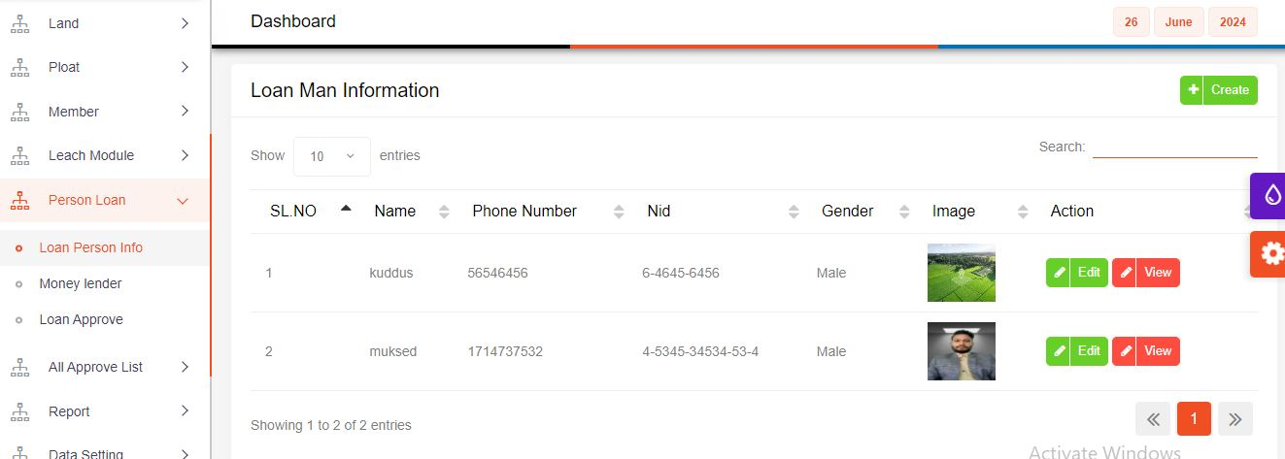

* When you click the create button on this a modal page, will open.

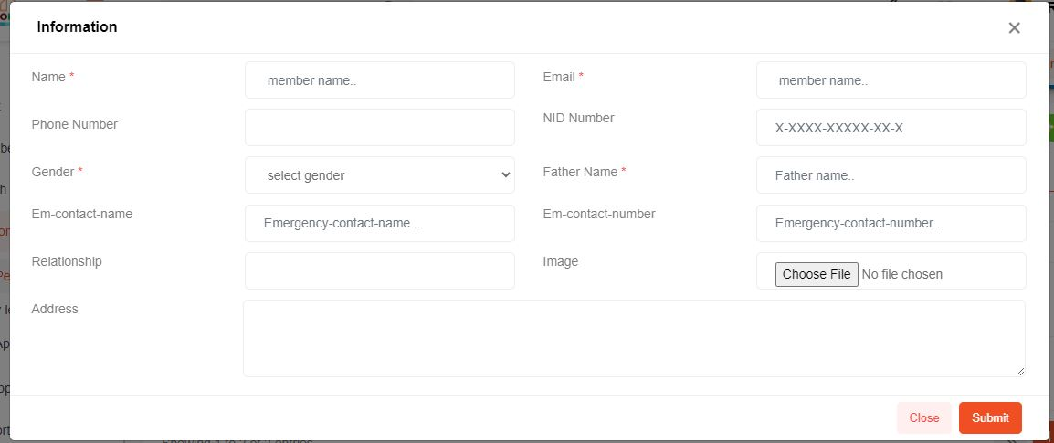

* When this form is submitted, all fields will be inserted as values, and upon clicking the submit button, the loan man information data will be saved

**Money Lender Page**

* If you click on " Money lender" from the menu, the "all money lender index" page will be displayed

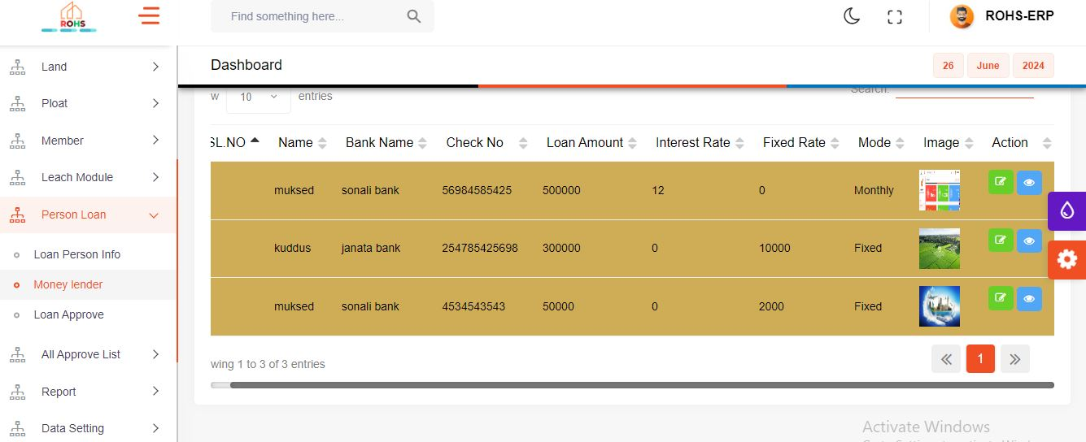

* When you click the create button on this a modal page, will open.

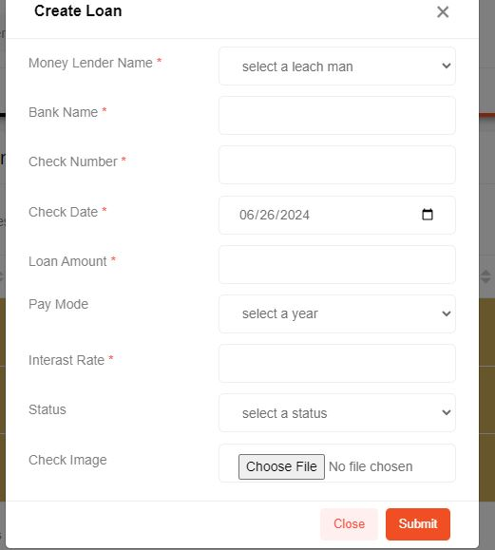

* When this form is submitted, all fields will be inserted as values, and upon clicking the submit button, the loan data will be saved

**Loan Approve Page**

* If you click on "Loan Approve" from the menu, the "all loan approve list" page will be displayed

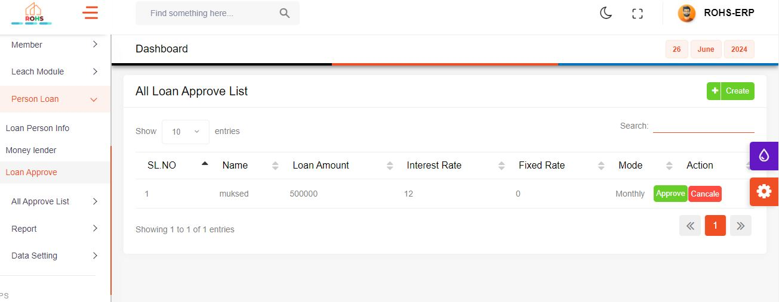

**Plot Distribution**

* If you click on "plot distribution" from the menu, the "plot details distribution" page will be displayed

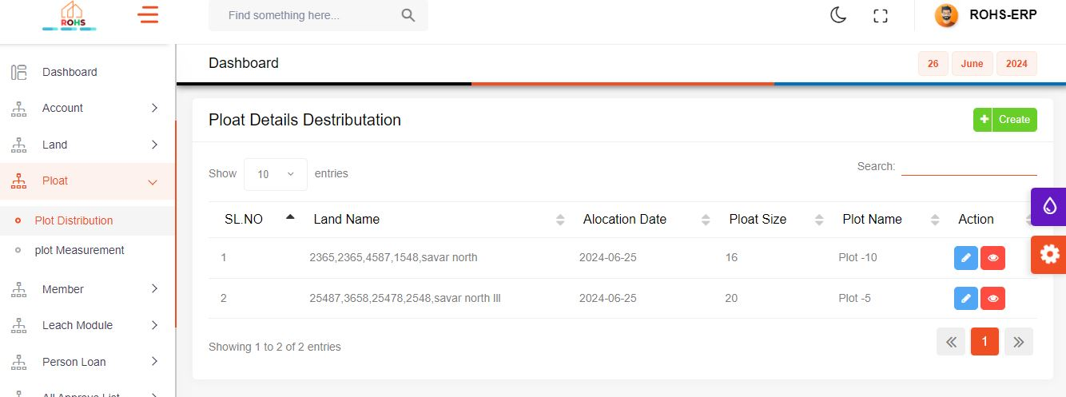

* When you click the create button on this a modal page, will open.

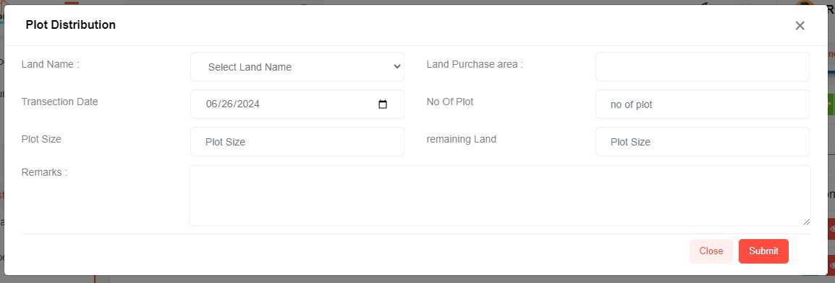

* When this form is submitted, all fields will be inserted as values, and upon clicking the submit button, the plot distribution will be saved

Plot measurement page

* If you click on "plot mesurement" from the menu, the "plot mesurement" page will be displayed

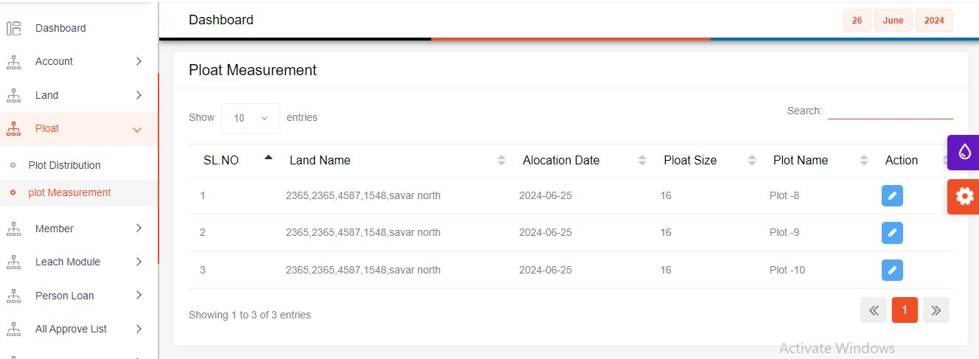

* When you click the create button on this a modal page, will open.

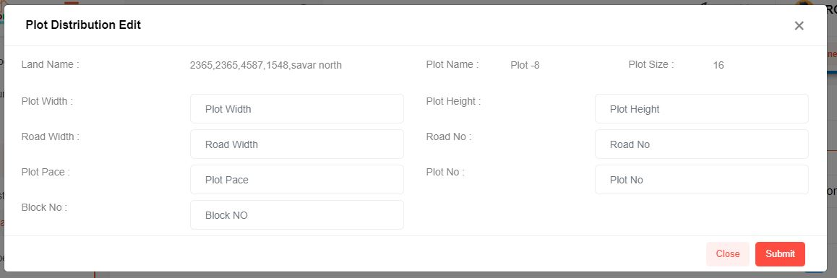

* When this form is submitted, all fields will be inserted as values, and upon clicking the submit button, the plot measurement data will be saved

**Loan Report Page**

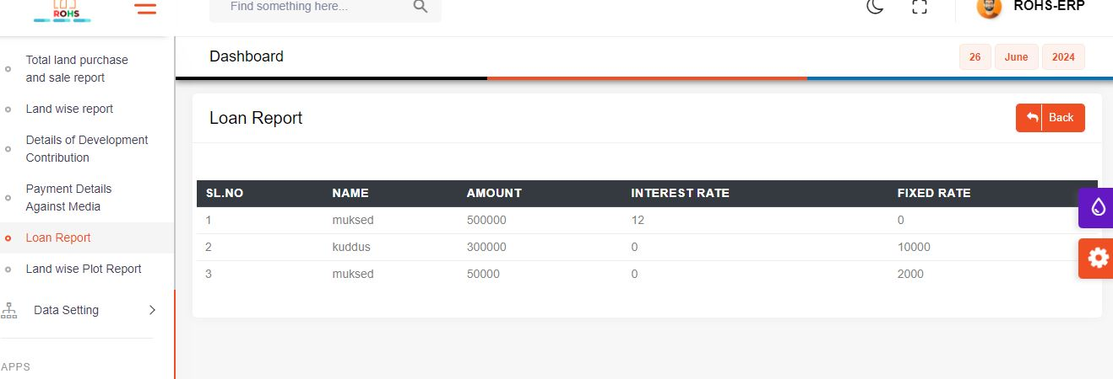

**Land wise Plot report**

